

**AI 894: Design & Implementation of AI Systems**

***Automated Narrative Creation of Collisions Involving a Pedestrian, Bicycle, or Micromobility Device***

***Project 7***

*Daniel Zielinski*

**Master of Artificial Intelligence (AI)**

**FA 2024**

Instructor: Wang Chengfei, Ph.D.

**Document Control**

**Work carried out by:**

|  |  |
| --- | --- |
| **Members** | **Email Address** |
| Daniel Zielinski | dzielinski06@runbox.com  djz133@psu.edu |
|  |  |
|  |  |

**Revision Sheet of Contributions**

|  |  |  |  |
| --- | --- | --- | --- |
| **Release No.** | **Date** | **Member** | **Revision Description** |
| 1 | 9/8/2024 | Daniel Z | Initial Draft |
| 2 | 9/15/2024 | Daniel Z | Added data pipeline diagram and abstract to proposal |
| 3 | 9/22/2024 | Daniel Z | Added content to lesson 4 – System Design and Infrastructure: System diagram, System requirements (functional; non-functional; ethics/safety; future considerations/out-of-scope) |
| 4 | 10/6/2024 | Daniel Z | Added content to lesson 6 Preprocessing and AI Planning section describing the data ingestion and management process. Minor updates to the Model Planning section. |
| 5 | 10/20/24 | Daniel Z | Completely overhauled section Lesson 6 on Preprocessing and Model Planning. Discussion of model parameters and decisions related to structure and inputs were primarily discussed here instead of under the lesson 8 label. Added content to Lesson 8 related to Model Validation. |
| 6 | 11/3/24 | Daniel Z | Some updates to this document in section describing model – switched model from Mistrai to Gemini – Added some content to Lesson 10 related to model deployment, but this section is incomplete as the model is not yet deployed. |
| 7 | 11/13/24 | Daniel Z | Complete overhaul of section 12 of model deployment and continual learning reflecting significant restructuring and buildout of code to encapsulate a GUI presentation of functions. |
| 8 | 11/17/24 | Daniel Z | Addition to section 12 for ethical considerations related to privacy and transparency. |
| 9 | 11/23/24 | Daniel Z | **Project Proposal** - Added description of City of Cleveland. Tweaked description of data and ethics section. Removed project goal of intersection-level summarization and validation of PSIP project as this requires too much GIS-specific effort for a valid comparison to existing engineer processes.  **System Design and Requirements** –  Replaced hand-drawn process flow with Visio-produced process flow.  Removed FR-05/13 because no longer relevant.  Updated FR-06 to reflect narrowed classification model.  Moved FR-08/09/10/16 to OOS-FR-04/05/06/07 due to complexity required to perform a valid GIS analysis.  Combined Lesson 8 into Lesson 6 to streamline explanations of preprocessing, modeling, and evaluation.  Removed Lesson numbers and remaining assignment guidance.  Added final discussion and summary analysis  Compiled all citation to end |

**TABLE OF CONTENTS**

Project Proposal – 4

AI System Design and Infrastructure - 24

Data Capture and Preparation – 29

Data Preprocessing, Building, Training, and Testing – 38

Model Deployment and Continual Learning – 51

AI Ethics – 58

Discussion - 64

# Project Proposal

**Purpose:**

This project intends to create a system to describe and categorize automobile-versus-pedestrian and bicycle collisions by extracting unstructured raw text from dispatch and police reports. The output of this system will be compared to state-reported collision data. Past research has found that only about half of ped/bike collisions are estimated to be reported to official structured records. This project aims to gauge and confirm the degree of pedestrian and bicycle under-reporting in Cleveland, Ohio and attempt to operationalize details lost in the current cataloguing process.

1. **Project title**

Automated Narrative Creation of Collisions Involving a Pedestrian, Bicycle, or Micromobility Device

1. **Keywords: discipline / application**
   * 1. **Disciplines**: NLP Classification, Generative AI, Applied Statistics
     2. **Application domains**: Transportation, Traffic Engineering, Law Enforcement
2. **Background and Challenges**
   * **Related Organizations and Initiatives**
     1. **Bike Cleveland (AKA BikeCLE)**

Mission Statement: "*[Bike Cleveland is a] 501(c)(3) advocacy non-profit for people on bikes in the Greater Cleveland area. Representing over 1000 due paying members and more than 32 local businesses, we make sure that any time the conversation turns to transportation — that people on bikes are being considered alongside people in cars. We work to improve policy, infrastructure, and legislation to help make our roads places that serve people and communities, not just traffic.*” (Bike Cleveland, 2015)

This group maintains a website here: <https://www.bikecleveland.org/>

Part of Bike Cleveland’s advocacy efforts have involved collecting and disseminating information about pedestrian and bicycle collisions in the Cleveland area. This effort began as an automated Twitter Bot that posted the location of 911 police dispatches involving a pedestrian or bicycle. After a substantial number of police dispatches were collected, Bike Cleveland compared the tweeted dispatch reports to state-mandated OH-1 reports and discovered less than half of dispatch records, which clearly described a bicycle or pedestrian collision, had a corresponding OH-1 record. This prompted a discussion among group members and an effort has been led by the group to advocate for better reporting by city officials.

* + 1. **City of Cleveland and Cleveland Police**

The City of Cleveland is a municipality in Northeast Ohio, located on the Southern shore of Lake Erie and was founded in 1796. In 2023, Cleveland had a population of about 362,000 and was the second largest population in the state of Ohio, following Columbus (U.S Census, 2023). For cities with more than 250,000, Cleveland Police rank in the 14th percentile of funding, has 38.9 police officers per 10k residents, and received a score of 35% (100% as best) from <https://policescorecard.org/oh/police-department/cleveland> (Police Scorecard, n.d.).

* + 1. **Vision Zero**

A type of government program which seeks to eliminate serious injury and death caused by traffic violence. The City of Cleveland has adopted a Vision Zero Action Plan resolution which aims to eliminate death and serious injury on Cleveland roads by 2032. This initiative is outlined on a website here: <https://www.visionzerocle.org/pages/action-plan> (Cleveland VZTF, 2022)

* + **Data Sources**

**Text/Feature Data**

The data for this project is sourced from Bike Cleveland and their ongoing effort to collect, publish, and advocate for street designs that are safe for cyclists and pedestrians. Feature data will consist of two inputs:

1. **OH-1 crash reports** are sourced from the Ohio Crash System Tools: <https://www.transportation.ohio.gov/programs/highway+safety/highway-safety-resources/08-crash-trends-resources> and are stored in PDF format. All types of collisions are available from this source, but this project will focus only on those involving a pedestrian, bicyclist, or person using a micromobility device (aka - scooter). These PDFs are generally consistent and use the layout described in this procedure manual: <https://dam.assets.ohio.gov/image/upload/publicsafety.ohio.gov/HSY7010.pdf>. Basic information, such as location and date/time, is stored in a structured file, referred to as GCAT. Some information, such as collision narratives, is not extracted into the GCAT structured data and will require using OCR to strip text out of a certain area within each report to be used as a feature input. It may be possible to extract information from the diagram drawings, but this may be unnecessary if the text inputs produce acceptable results. A challenge with using these PDFs is that in 2023 Cleveland Police started using a computer system to create OH-1 reports. Reports from 2022 and prior are mostly hand-written and extracting the text is not feasible. Also, because the older reports weren’t produced in a centralized and consistent manner, the “Local Report Number” is inconsistent making association of OH1s to structured data in GCAT difficult or impossible.

Page 1 OH-1:

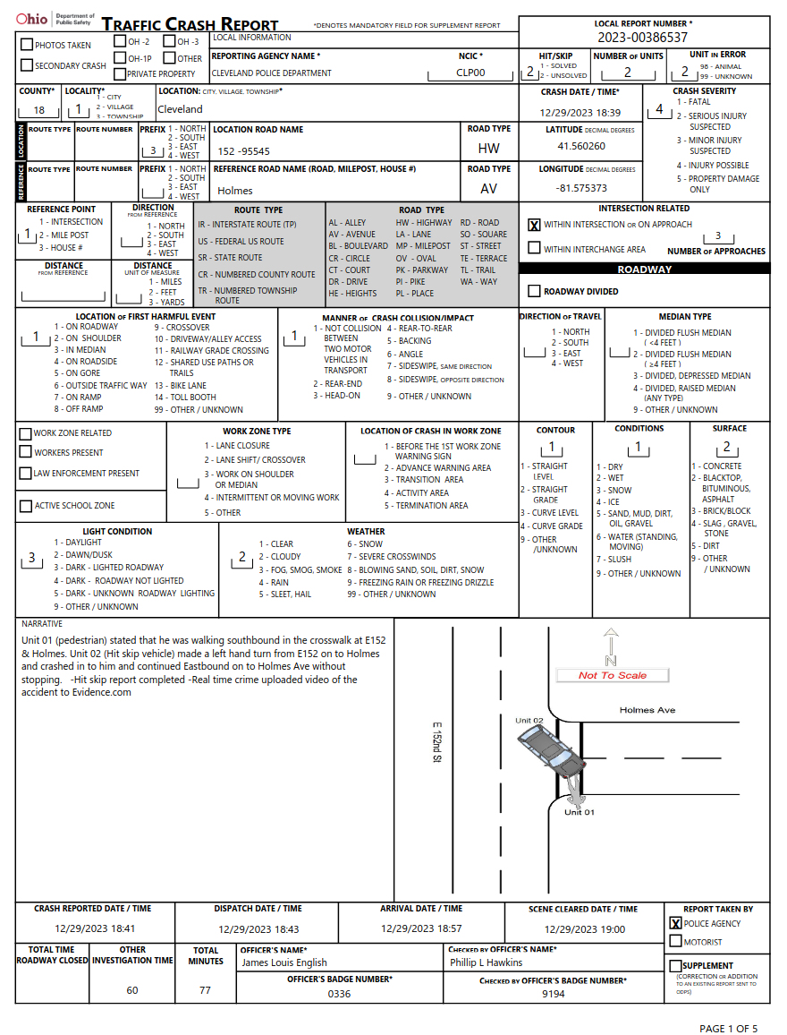

(Figure 2.1 - Sample first page of OH1 Report)

1. **Police dispatch records** have been gathered through a campaign of bot-driven public records requests to the City of Cleveland’s Public Records Request Center for dispatches categorized as “pedestrian-struck.” <https://clevelandoh.govqa.us/WEBAPP/_rs/supporthome.aspx> . These files stored as text-only PDF files so it should be straight-forward to extract text using OCR from these documents. All iterations of information are included in each file reflecting iterations of information as a dispatcher receives it. So, information later in this text is more accurate than earlier information. Also, dispatchers use a lot of acronyms to reduce the keystrokes needed to receive and send information quickly. Preprocessing of the text from “CLR STS” to “Caller states” will likely be required to be able to fully leverage LLM tokens. This is an important point and anticipated to be a particular challenge for Llama, which is intended for use to supplement the narrative creation. Example of police dispatch notes:

Sample of CAD report:

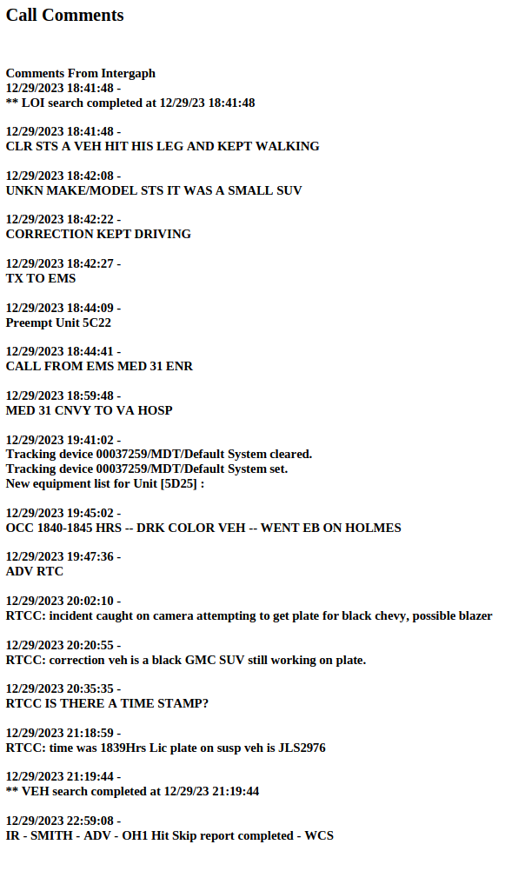

(Figure 2.2 - Sample page of CAD report)

**Narratives/Labels** are sourced from a data store hosted by Bike Cleveland and published through an AWS web portal: <https://czt313d2a2.execute-api.us-east-1.amazonaws.com/dev/filter>

which features a graphical interface listing collision summaries and offers basic filtering function. An example is shown here:

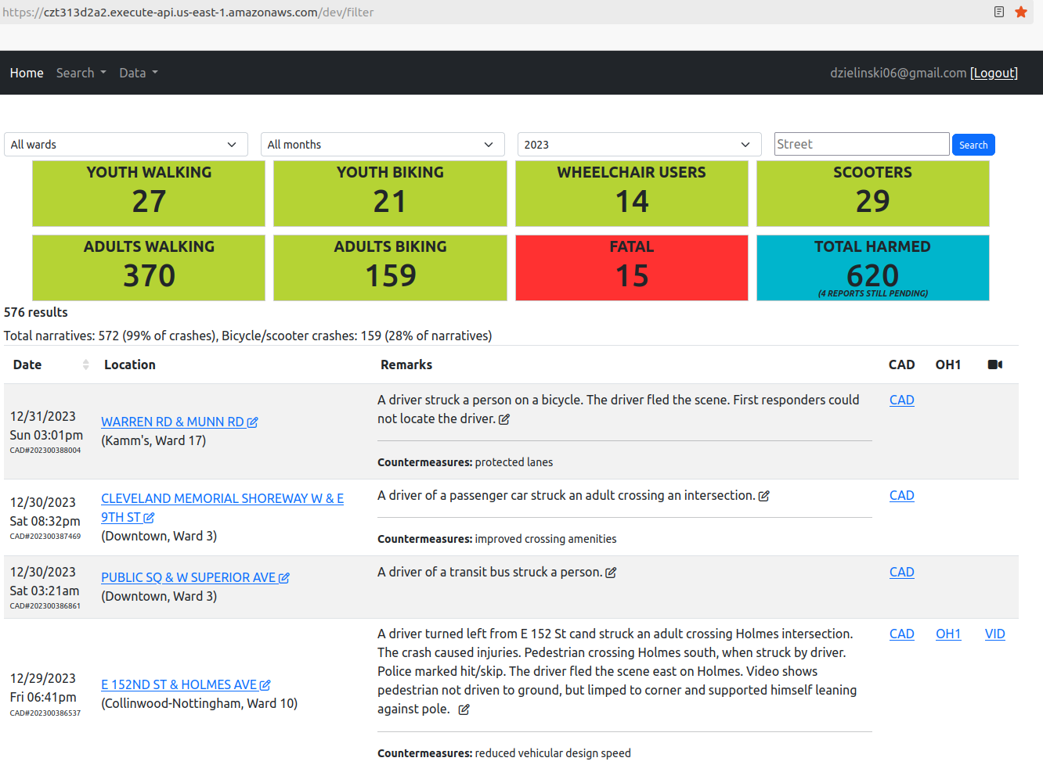

(Figure 2.3 - Screenshot of Bike Cleveland collision repository)

These narratives were entered by volunteers who have read the dispatch and OH-1 reports and generated “Remarks” to summarize the collision and are extracted into a csv file. This data is the result of a year’s long project at Bike Cleveland (BikeCLE) to catalog all pedestrian and bicycle collisions in the City of Cleveland. An anticipated challenge with this data is that older entries to this project were completely free-text. Recently, the process was improved to impose quality on entries into a drop-down form that produces a sentence narrative, like this:

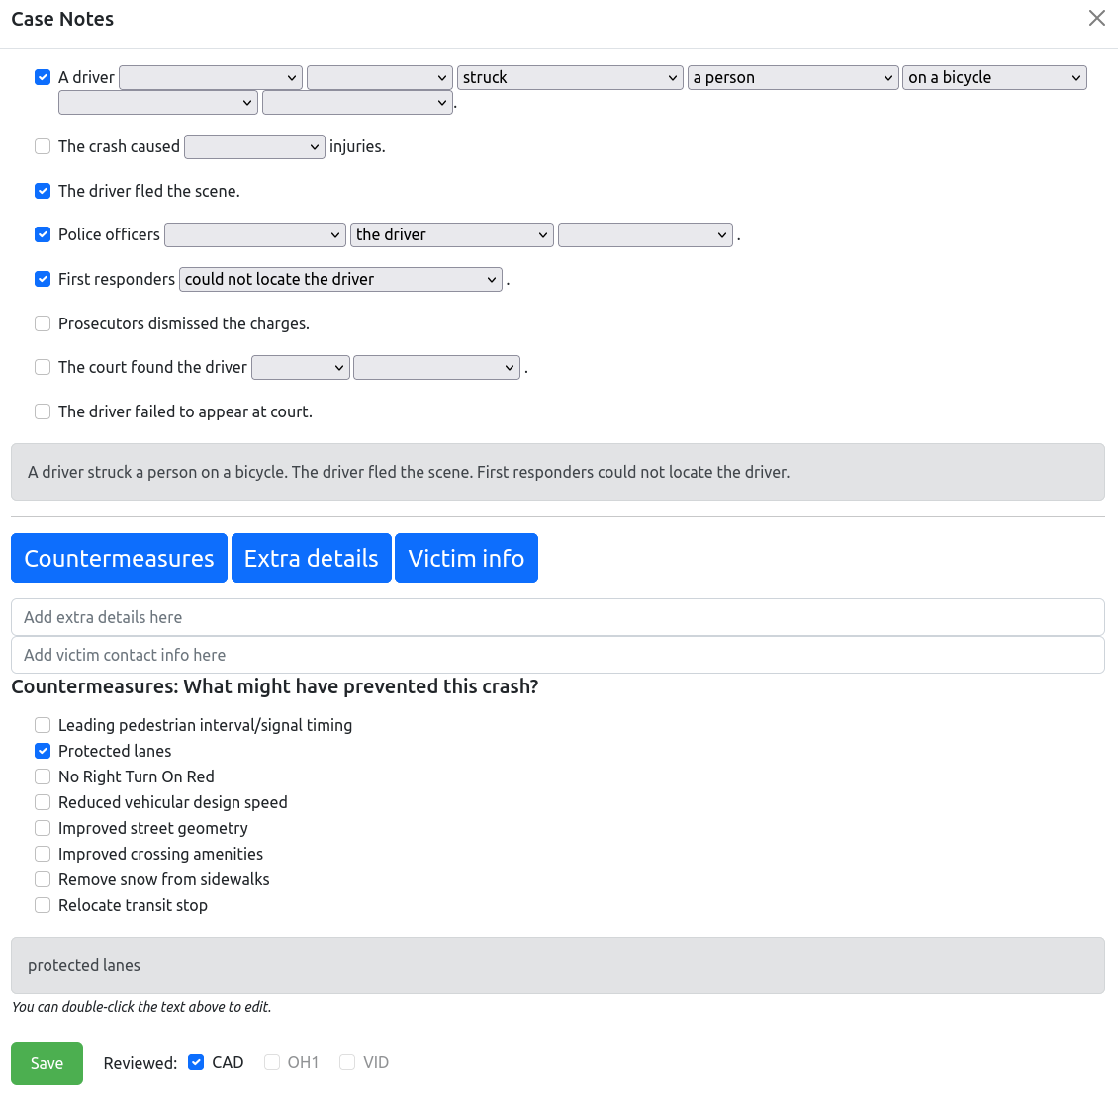

(Figure 2.4 - Screenshot of Bike Cleveland collision database entry portal)

This helps with speed and ease of data entry and label consistency for recently created labels. Older narratives may contain unneeded information that introduces unneeded information and hinders the model’s quality and encourages hallucinations.

* + AI Ethical Challenge

The production of this data relies on communication between humans and data entry by humans, so it’s certain that intrinsic biases held by the humans behind these reports will be imperceptibly embedded in a model using them. This is especially true for dispatch reports as these reports are momentary impressions communicated over the phone and keyed into a computer system as quickly as possible. The audio of the 911 calls are not the focus of this project, but some are available in this dataset. The project's main goal is to test if text from these reports in meaningful and can be operationalized to capture details otherwise lost.

Entries from volunteers for collision remarks may introduce bias from the volunteers themselves. However, with a considerable number of the narratives entered with drop down selections, this should be limited. The design and aim of this project have been selected in such a way as to limit the concern of AI-perpetuated biases.

Information in these reports is sensitive and sometimes documents the most traumatic, or last, moments of a person’s life. Delicate and careful consideration will be made when referring to serious injury and fatal events. Effort will be taken to shield names and sensitive information as much as possible from the process.

1. **Project Objectives**

Existing research in understanding underreporting of pedestrian and bicycle collisions has focused on quantifying the extent and nature of collision underreporting. This project seeks to confirm this effect and attempt to recapture and make the information lost in that under-reporting usable.

1. Extract text from Computer Aided Dispatch (CAD) reports with OCR
2. Extract officer-narrative field from OH1 reports using an machine vision edge detector to identify the appropriate region.
3. Concatenate text from CAD and OH1 reports and input it into two models running in parallel:
   1. Predict if collision was severe or not severe
      1. This will be called the “GCAT Model” (GIS Crash Analysis Tool)
   2. Generate a summary narrative of events for each collision
      1. This model will be called the “BikeCLE Narrative Model.”
      2. The characteristics of interest for description within the BikeCLE Narrative model are:

**Driver vehicle type**:

* Unknown

* Car

* Large Passenger Vehicle

* Very Large Vehicle

* Motorcycle or Micro-mobility Device

**Maneuvered**:

* Unknown

* Straight

* A Left Turn

* A Right Turn

* Backward

* Vehicle as Weapon {maybe}

**Pedestrian Type:**

* Unknown

* An Adult

* A Child

* Multiple People

**Pedestrian vehicle type**:

* Unknown

* On Foot

* A Bicycle

* A Micro-mobility Device

* A Wheelchair or Stroller

**In the Area Of**:

* Unknown

* An Intersection

* Mid-block

* A Bike Lane

* A Driveway

1. **Feasibility Studies**

**4.1 Scientific Survey**

* Keywords

Machine Vision Edge Detector

Optical Character Recognition (OCR)

NLP categorization

NLP summarization - Generative AI

Car Accident Underreporting

* Similar Past Projects and Research

Doggett is the closest recent analog to this project and seemed closest to operationalizing multiple data sources into the underreporting gap:

Doggett, S., Ragland, D. R., & Felschundneff, G. (2018). Evaluating Research on Data Linkage to Assess Underreporting of Pedestrian and Bicyclist Injury in Police Crash Data. *UC Berkeley: Safe Transportation Research & Education Center*. <https://escholarship.org/uc/item/0jq5h6f5>

Hauer and Scott have explored the theme of collision underreporting but because these papers are dated, they are cited here to establish a timeline for how long this problem has been known and to highlight the intractability of the underreporting problem:

Hauer, E., & Hakkert, A. S. (1988). Extent and Some Implications of Incomplete Accident Reporting. Transportation Research Record, 1185. <http://onlinepubs.trb.org/Onlinepubs/trr/1988/1185/1185-001.pdf>

Scott, Robert, & Carroll, Philip. (1971). Acquisition of Information on Exposure and on Non-Fatal Crashes - Accident Data Inaccuracies Vol. II. *Highway Safety Research Institute, The University of Michigan Ann Arbor, Michigan*. <https://deepblue.lib.umich.edu/bitstream/handle/2027.42/1054/15848.0001.001.pdf>

Abay, Ahmed, and Khadka are broad explorations of collision underreporting trends and characteristics:

Abay, Kibrom A. (2015). Investigating the nature and impact of reporting bias in road crash data. *Transportation Research Part A: Policy and Practice*, *71*, 31–45. <https://doi.org/10.1016/j.tra.2014.11.002>

Ahmed, A., Sadullah, A. F. M., & Yahya, A. S. (2019). Errors in accident data, its types, causes and methods of rectification-analysis of the literature. *Accident Analysis & Prevention*, *130*, 3–21. <https://doi.org/10.1016/j.aap.2017.07.018>

Khadka, Anish, Parkin, John, Pilkington, Paul, Joshi, Sunil Kumar, & Mytton, Julie. (2022). Completeness of police reporting of traffic crashes in Nepal: Evaluation using a community crash recording system. *Traffic Injury Prevention*, *23*(2), 79–84. <https://doi.org/10.1080/15389588.2021.2012766>

Nauman explores an action plan for implementing Vision Zero safety improvements by improving organizational networks within large cities. This is an interesting idea for operationalizing solutions but is too far out of scope to include these ideas in the current project.

Naumann, Rebecca B., Heiny, Stephen, Evenson, Kelly R., LaJeunesse, Seth, Cooper, Jill F., Doggett, Sarah, & Marshall, Stephen W. (2019). Organizational networks in road safety: Case studies of U.S. Vision Zero cities. *Traffic Injury Prevention*, *20*(4), 378–385. <https://doi.org/10.1080/15389588.2019.1587752>

* Difference of this project from past work.

The current project accepts the findings of past work, but this work has functioned to quantify and characterize underreporting. The intention of this project is to establish a method to operationalize under-reported data. This project also differs from other work in the focus on police dispatch reports instead of hospital data.

**4.2 Technical Survey**

* Similar Commercial Products:

AASHTO Safety Software is SAAS licensed product used to screen intersections and sections on collision metrics and aligns with objective 3 of this project: <https://www.aashtoware.org/products/safety/safety-overview/>

* Related Technical Projects

This project is intended to augment an existing documentation project at Bike Cleveland posted here: <https://czt313d2a2.execute-api.us-east-1.amazonaws.com/dev/filter>

Objective 1 of this project will create a two-step AI pipeline of two distinct ML models. The first will be an NLP categorization model identifying unit characteristics, and the second will be an LLM to produce a GenAI summary narrative:

A related example of an on-device application of the Llama LLM is ‘easy-llama’ here: <https://github.com/ddh0/easy-llama>

Another loosely related example makes use of images in the pipeline, and while it’s not anticipated be part of the first iteration of this project, a related example doing this is here:

<https://github.com/Rajeevsinghsisodiya/Integrating-LLaMA-Language-Model-with-FLUX-Pipeline-for-Enhanced-Image-and-Text-Generation>

* Difference of Current Project from Existing Commercial Solutions

This project will differ from the AASHTO’s SAAS Safety Software because it will include data that is historically underreported.

**High-Level Description of System**

This is a novel dataset sourced through a years-long campaign of public records requests performed by Bike Cleveland. Text from police dispatch PDFs and OH-1 narratives (when available) will be converted into string variables and used as input into a predictive ML model to categorize unit types. Those outputs, and the original text, will be used as prompts for a fine-tuned LLM with the goal of summarizing original text. After text is classified and narrated, an evaluation of under-reporting will be performed and a dataset will be available for in-depth GIS, and other, analysis.

**Importance and Impacts**

The recommended first step in a data-driven traffic safety study is to collect data (ODOT, 2022) and the only recommended data is confirmed crashes submitted to the state on OH-1 reports. The only way to make an OH-1 record of a collision is by making a report to a police officer. While reports may be made to an officer through any interview, this process most often starts through the 911 phone system and the police dispatch. However, ‘pedestrian-struck’ dispatches don’t always result in a police officer creating a report. A notable percentage of time first responders will go to a location only to find all the relevant parties have left the scene. The result is a discrepancy between evident collisions in dispatch records and OH-1 reports. Past research has identified underreporting of pedestrian and bicycle collisions as a severe issue with estimates ranging “from 44 to 75 percent for pedestrian crashes, and from 7 to 46 percent for bicycle crashes” (Doggett, et al, 2018). Preliminary analysis of the current dataset partially confirms these findings with only 49% of pedestrian-struck dispatches having an associated official OH-1 collision report in 2023.

Once created, police submit OH-1 reports to the state for inclusion in the Ohio Crash System Tools. Use of state-provided Crash System Tools, such as *GIS Crash Analysis Tool (GCAT),* *Crash Analysis Module* (*CAM) Tool,* and *OSTATS Public Crash Dashboard* are the recommended data sources and crash-analysis tools from the Ohio State Highway Patrol (OSHP), despite the disclaimer “only confirmed crashes are in the Crash System” (OSHP, 2024).

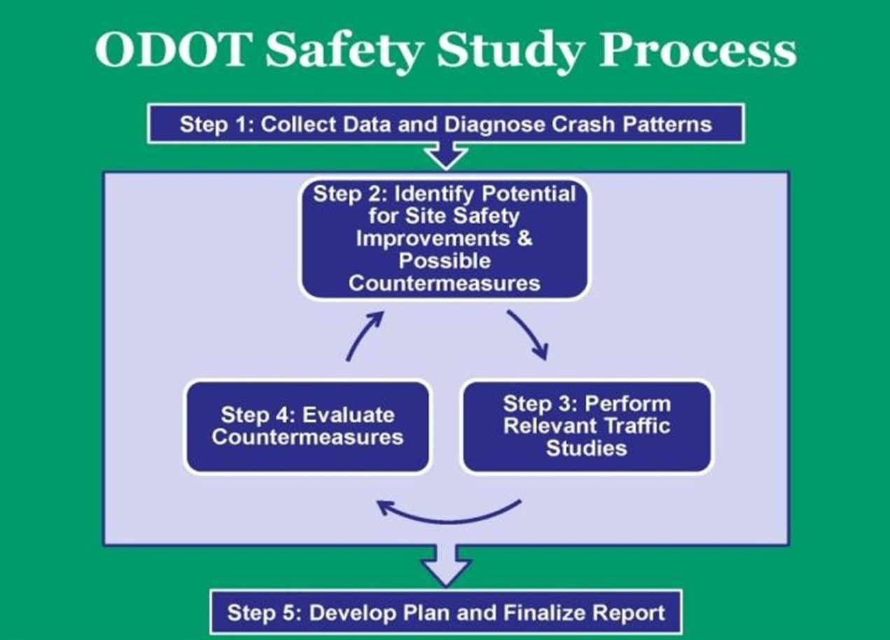

(Figure 2.5 - OSHP, 2024 Safety Study Process Flow)

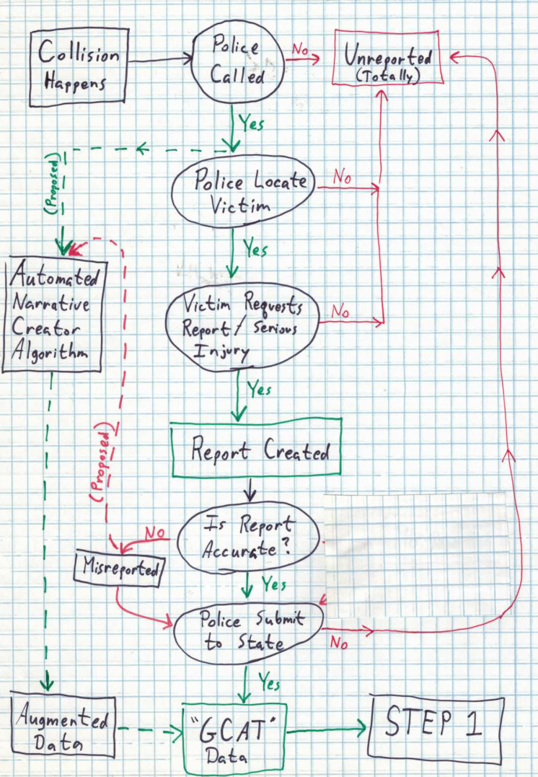

(Figure 2.6 - Simplified current and proposed information pipeline of collision information prior to “Step 1”)

**Survivorship Bias**

The classic study by Abraham Wald '*Estimating Plane Vulnerability Based on Damage of Survivors*’ demonstrated how survivorship bias can trick an audience into believing an unsafe assumption that data with specificity is also comprehensive (Wald, 1980). By counting the location and quantity of bullet holes in airplanes returning from combat, Wald points out observations were only being made of planes that were not shot down. The bias is almost comically obvious when one infers that the most harmful bullet holes are likely unobserved because the plane crashed. A similar bias is likely occurring in collision data but for low injury incidents.

City of Cleveland pedestrian or cyclist safety initiatives adhere to the OHSP recommendation and only use state-provided GCAT data in the *Vision Zero* and *Speed Table Program* (Cleveland, VZTF 2022; Cleveland, 2023). Because only OH-1data is used, this begs the question: “*are all crashes officially reported*?” The existence of under-reporting in collision data extends back more than 50 years with Scott and Carrol stating in 1971, “Highway accident data are seriously biased due to under-reporting” (Scott, 1971). It's curious then to see diagrams from modern safety studies commissioned by ODOT (Crawford, 2018) that do not mention, or seem to consider, underreporting in their analysis. Indeed, diagrams in these studies have an eerie similarity to diagrams of airplanes studied in Wald’s analysis:

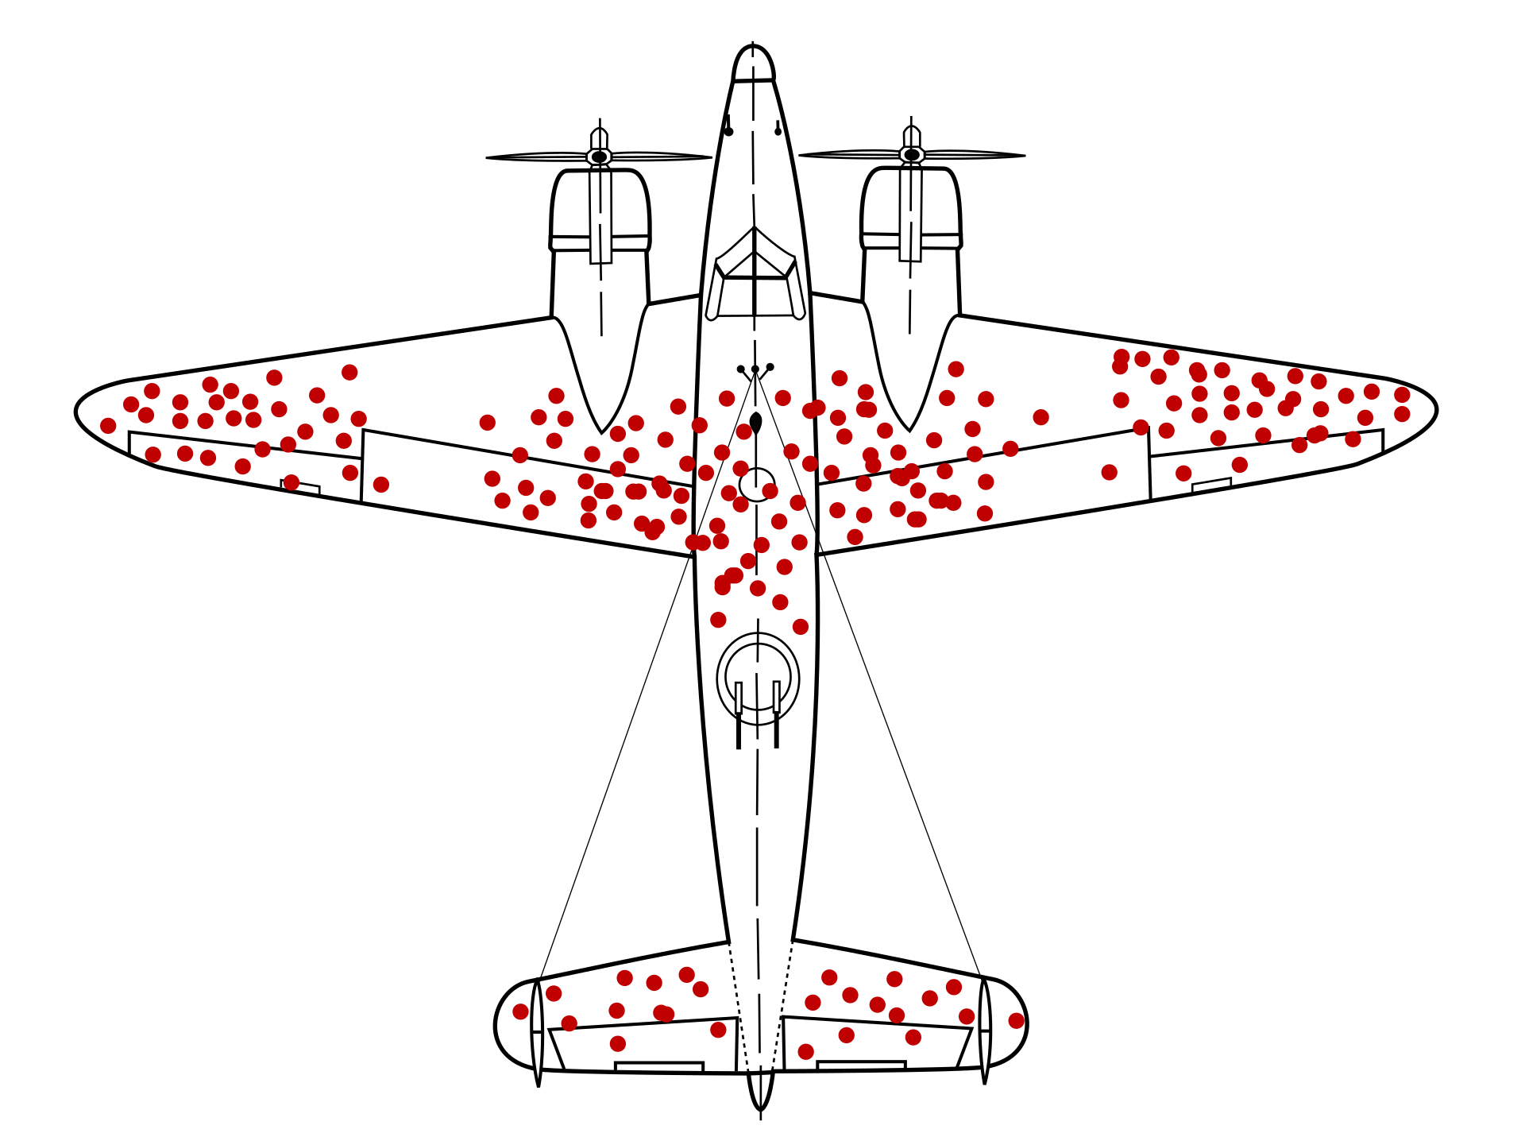

(Figure 2.7 - Survivorship Bias Illustration of WWII Bomber Plane (Moll, 2022))

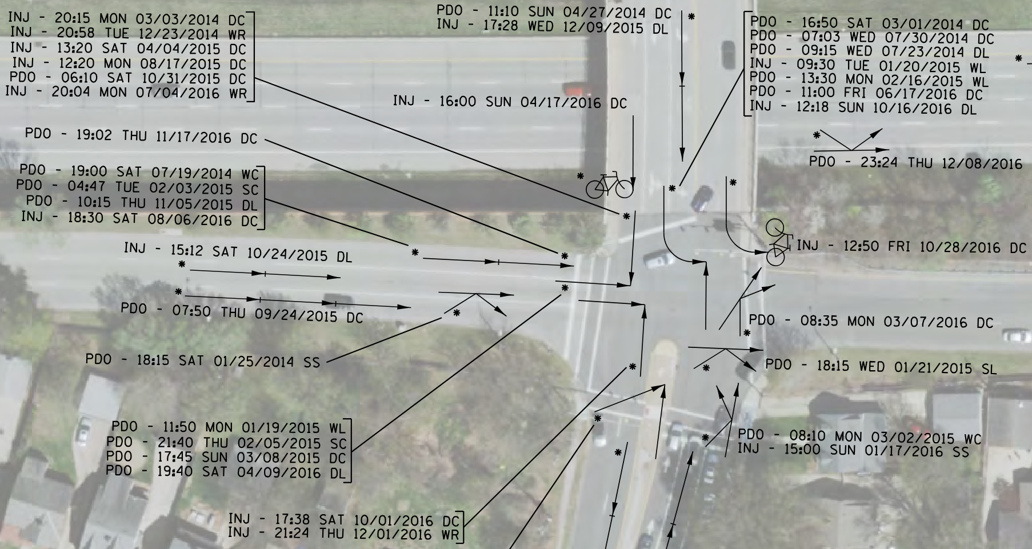

(Figure 2.8 - HSIP Intersection Safety Study (Crawford, 2018))

Studies of collision underreporting postulate that underreporting has a negative relationship along two axes: income, and injury severity (Ahmed, 2019; Abay, 2015; Khadka, 2022; Scott, 1971). Therefore, as underreporting increases so does the probability of incorrect forecasting, erroneous attribution of crash contributing factors, and mis-prioritization of funding and safety initiatives (Ahmed, 2019). Said otherwise, state-recommended engineering methods applied by the City of Cleveland may be inadvertently discounting pedestrian and bicycle safety because records of these collisions do not ‘survive’ the data collection process.

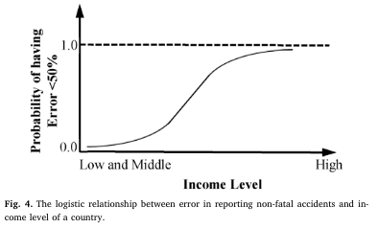

(Figure 2.9 - Reporting probability based on income (Ahmed, 2019))

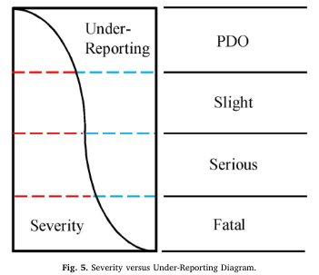

(Figure 2.10 - Reporting probability base on severity (Ahmed, 2019))

**Overcriminalization as Contributor of Selection Bias**

While not the primary focus of this project, it is illustrative to explore how over-criminalization might interact with this collision data and discuss some cases observed in the current data.

In the early 1980s, Ronald Reagan proclaimed victims of crimes as “forgotten persons” (Reagan, 1981) and enacting a series of *tough-on-crime* legal and budgetary reforms resulting in a dramatic increase of incarceration from the mid-1980s through the mid-2000s.

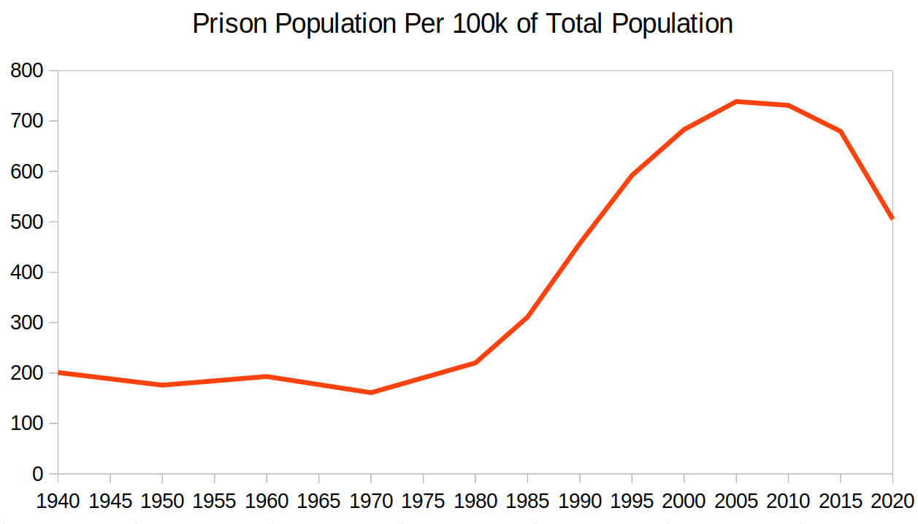

(Figure 2.11 - Prison population over time (World Prison Brief, 2020))

This shift in the American legal system is referred to as “overcriminalization” and has been studied extensively by the legal scholar community. It may be summarized as the existence of too many laws applied too broadly (Smith, 2012). There is near universal agreement, among groups ranging from the American Civil Liberties Union (ACLU) and The Heritage Foundation, that overcriminalization has broad negative societal impacts (Dillon, 2012). One complicating factor of overcriminalization is a paradox that the criminal perpetrators of today were often victims of unrelated crimes in the past (Green, 2019). This victim-to-criminal dynamic develops into a practically, or morally, unworkable relationship between law enforcement and victims when victims are most vulnerable. Because OH-1 collision reporting relies on information provided to police, such as name and date of birth, collision parties may be distrustful of the police and choose to avoid providing information or interacting with the police in any way.

An example illustrating this is that of a 59-year-old woman riding a bicycle struck by a driver causing serious injury. The woman was unable to leave the scene due to her injuries. Responding officers discovered she had an outstanding warrant from an unrelated drug charge. Even though she was not at fault police promptly arrested her. An even more serious example of underreporting is that of a 65-year-old man who had a lengthy criminal record, once described by a judge as “a menace” after inflicting serious injury on a young girl while fleeing police in a stolen vehicle. He served six years in prison but after his release was reported as fatally wounded by the coroner as a pedestrian in another traffic collision. This may be a reporting error by the coroner but, for reasons unclear, the OH-1 regarding this fatal collision was never submitted to the state. (As of this writing, the author has submitted public record requests to multiple agencies with no reply.) It’s unclear how much underreporting is driven by individuals and how much by reporting agencies. The state requires OH-1 to be submitted within five days of creation of a report (ORC, 5502), but examples of late reporting, non-reporting, and misreporting are observed in OH-1 data are common, even for fatalities. To quote Hauer “the problem of dealing with a rubbery yardstick is further complicated by the fact that not all that is reportable is reported” (Hauer, 1988).

After police and thoughtful consideration are rejected as a response to collisions, the systematic recourse offered through Crash System Tools and Vision Zero is potentially replaced with unsystematic and problematic behavior. There are troubling examples in this data of dispatches reading something like, “Juvenile struck by vehicle. Shots fired. EMS standing by for police to clear scene. All subjects gone on arrival.” Even in these cases, no OH-1 report is created and the root cause of the seminal incident is lost in the data. Whatever the root cause of underreporting, situations of perpetrator-to-victim cycles shows how deeply entrenched traffic violence can be on American roads and the potential for spiraling severity of underreporting in over-criminalized areas.

**Data Solutions**

It may be assumed that planners and decision makers do not want a community to be victimized repeatedly in the same manner because some evidence exists for consideration of economically disadvantaged areas. The data solution to this problem can be inferred from Appendix C of Cleveland’s Vision Zero Action Plan, which describes the summarization of collision data. This process provides for an adjustment factor to counteract the effects in economically disadvantaged areas (Cleveland VZTC, 2022).

While it is possible this is sufficient to counterbalance underreporting, a blanket factor is not without problems because it has the possibility to still allow blind spots of safety issues. For example, if two areas have the same economic adjustment factor but one area has greater underreporting then valuable infrastructure money may be applied in the area with less actual need. If planning initiatives rely mainly on comprehensive officer-generated reports, well-intentioned conclusions may fail to address traffic safety issues in over-criminalized areas.

Revisiting Ronald Reagan’s concern that “lack of concern for victims compounds failure [of our system].” The current project intends to create a solution to fill a 50-year gap in collision reporting. There have been gains made in adding structure to official reporting, like the OH-1, but it’s evident further gains are needed. It’s important for a community to be honest about traffic violence and reduce the actual and perceived risk of walking and cycling. Even after adjusting relative safety risk for underreporting, the health benefits of cycling outweigh the public health impacts of a collision injuries, but the perceived individual risk is disproportionally high and suppresses individual cycling activity (Götschi, et al., 2016).

**Required Technologies**

This project will be developed in Python using

* numpy = ">=2.0.0"
* pandas = ">=2.2.2"
* datasets = ">=2.14.5"
* torch = ">=2.0.1"
* Transformers = ">=4.34.1"
* nltk = ">=3.8.1"
* pdf2image = ">=1.16.3"
* pytesseract = ">=0.3.10"
* scikit_learn = ">=1.5.2"
* matplotlib = ">=3.9.2"
* seaborn = ">=0.13.2"
* accelerate = ">=0.26.0"
* opencv-python = ">=4.10.0.84"
* evaluate = ">=0.4.3"
* imblearn = ">=0.12.4"
* google-auth = ">=2.35.0"
* google-generativeai = ">=0.8.3"
* Flask = ">=3.0.3"
* spacy = ">=3.8.2"
* en-core-web-trf = {url = "<https://github.com/explosion/spacy-models/releases/download/en_core_web_trf-3.5.0/en_core_web_trf-3.5.0-py3-none-any.whl>"}
* tqdm = "^4.66.0"

1. **References**

# AI system Design and Infrastructure

The system is divided into three discrete sections: Batch Data Import, Modeling, and Output and Analysis. The Batch Data Import section focuses on bringing data into the system, cleaning, and assembling it into a useful format. The Modeling section focuses on creating, evaluating, and depoying the GCAT (GIS Crash Analysis Tool) classification model and the BikeCLE Narrative model. The Output and Analysis section contains the final scored dataset, which is the principal output of the process, and a simple summarization analysis displaying the degree of under-reporting of collisions in the data.

The high-level description of this system is

1. Manually capture data and files of individual events from external sources
   1. Note: The manual steps to retrieve original data from external sources require logins and ad-hoc requests. They are referred to in this project, but instructions to complete these steps is not included in this project. In lieu of detailed instructions to retrieve original files, the files and data have been included with the project submission.
2. Extract and clean data and text from those files
3. Preprocess and model patterns in the data to predict collision severity and to create a summary narrative
4. Summarize modeled data into an exhibit

The process of running this system involves a combination of steps requiring manual human effort, Jupyter notebooks, Python code, and Google’s AI Studio. An image of the process flow is included as a set of screenshots in Figure 4.1. A higher resolution version is available in the project package in the docs directory, or at this link:

<https://github.com/beardedDan/complete_collision_recorder/blob/main/docs/Process_Flow.pdf>

<https://github.com/beardedDan/complete_collision_recorder/blob/main/docs/process_flow.vsdx>

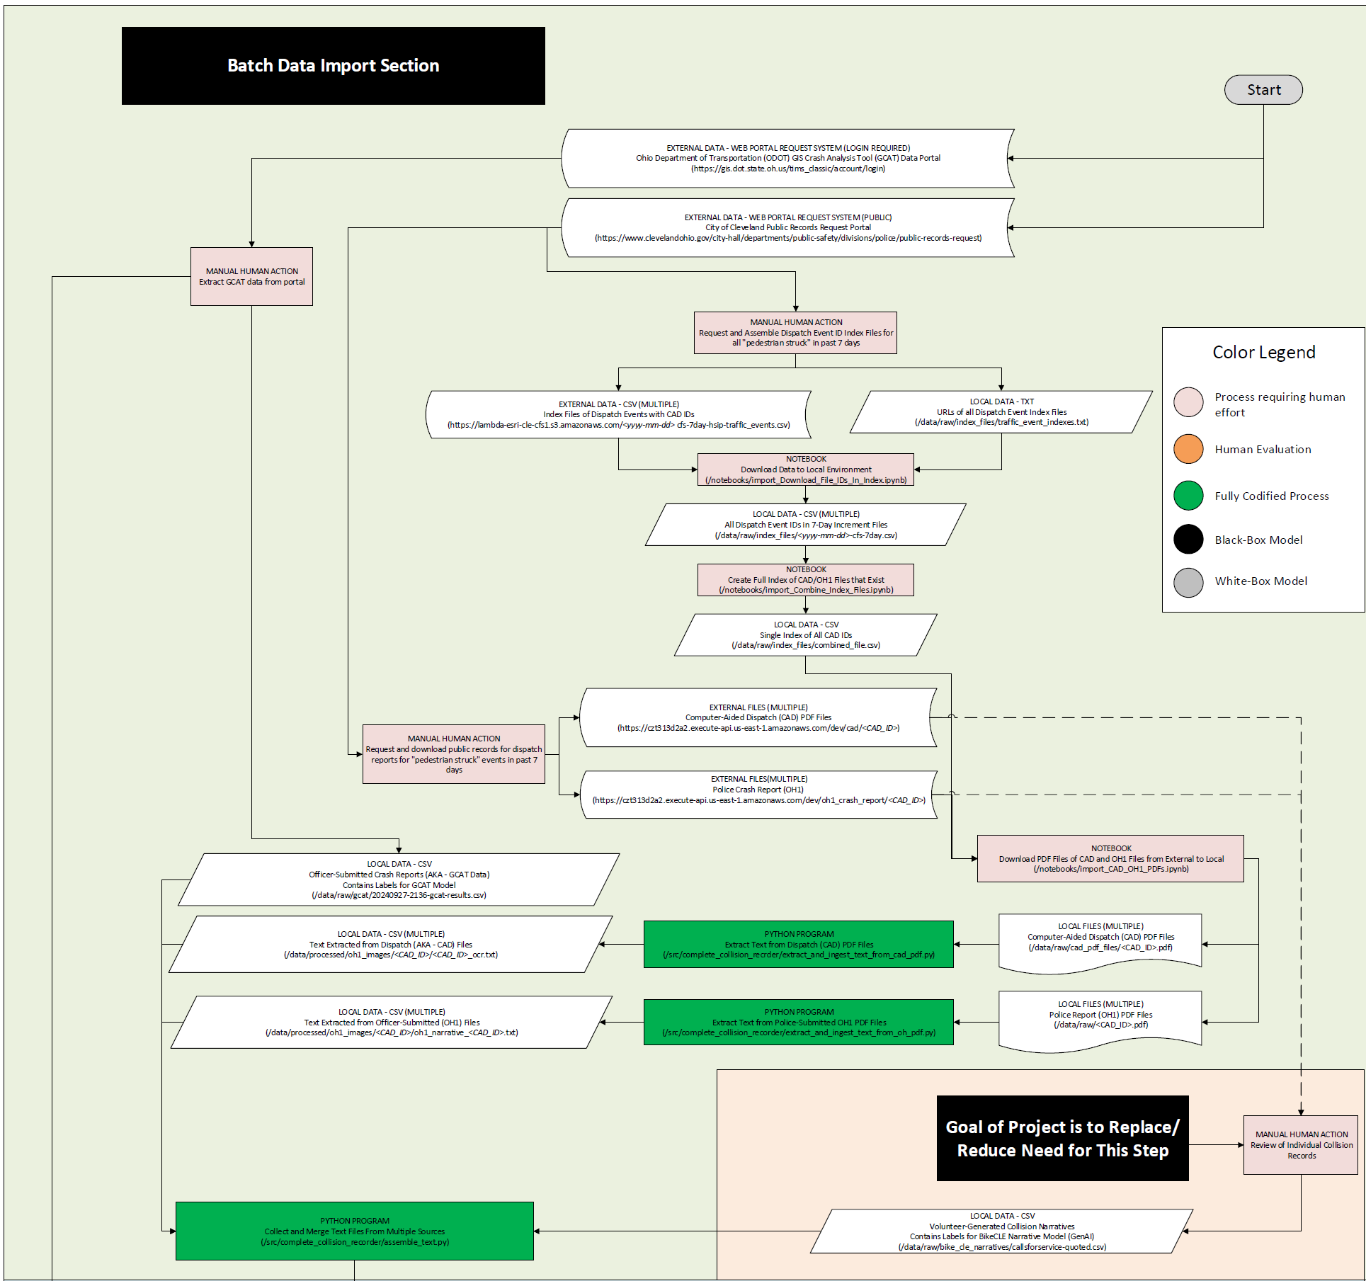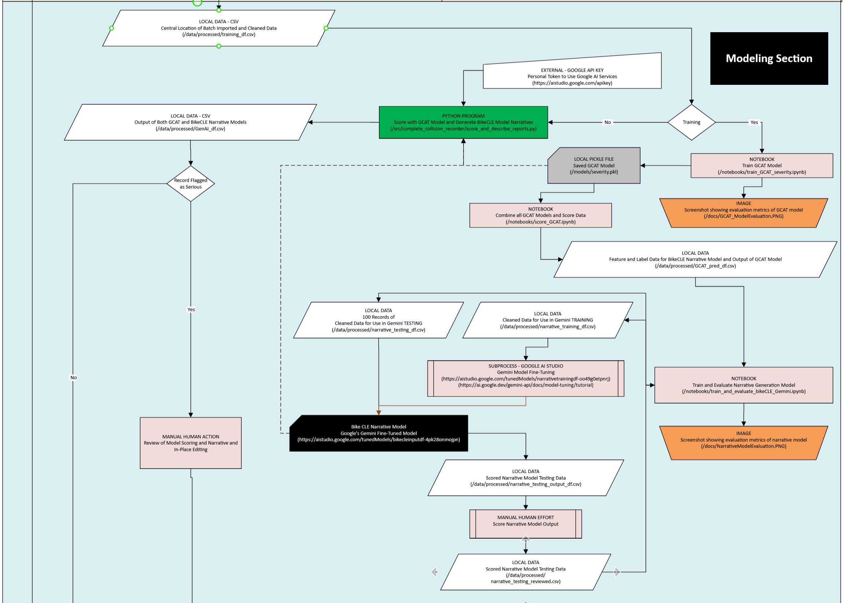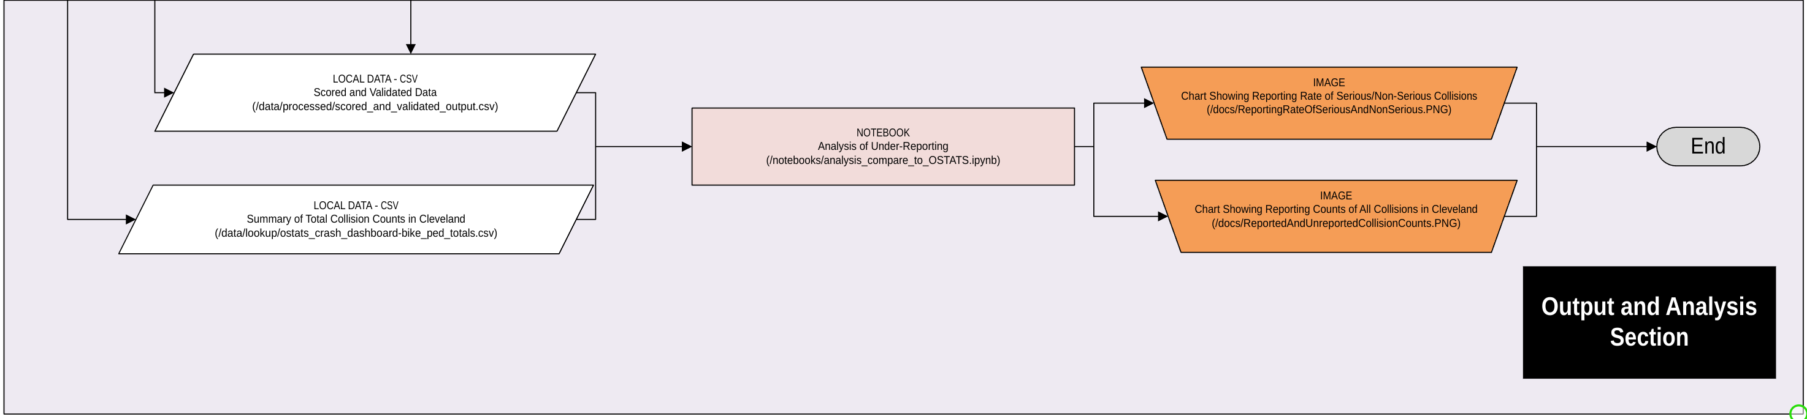(Figure 4.1 - Process Flow)

**Functional Requirements (FR)**

|  |  |  |  |  |
| --- | --- | --- | --- | --- |
| **Req ID** | **Description** | **Priority** | **Category** | **Verification Method** |
| FR-01 | Ingest police Computer Aided Dispatch (CAD) reports in PDFs form and convert to text using common Python OCR libraries (pdf2image, pytesseract) | High | Data Ingestion | Manual Review |
| FR-02 | Define layout and creating bounding boxes of OH1 crash reports and be able to extract specific entry boxes | High | Data Ingestion | Manual Review |
| FR-03 | Ingest OH1 crash reports from the State of Ohio in PDF form and convert officer narratives to text using common Python OCR libraries (pdf2image, pytesseract) | High | Data Ingestion | Manual Review |
| FR-04 | Clean and process OH1-derived “GCAT” data provided in structured format from state of Ohio | High | Data Preprocessing | Manual Review |
| FR-06a | Use a predictive model to categorize collision severity into two groups:   * Fatal or Severe * Minor Injury or Injury Possible | Medium | AI Modeling | Precision/Recall Measurement |
| FR-07 | Summarize individual collisions into a text narrative using NLP libraries (Transformers, nltk, PyTorch) | High | AI Modeling | Human Review (Accuracy) |
| FR-11 | Use GPU or parallel-CPU processing to train AI models | Medium | AI Modeling | Manual Review |
| FR-12 | Serialize AI models with the pickle Python module and embed in AWS-based web application and allow for updating of model without retraining | Low | AI Modeling | Manual Review |
| FR-14 | Detect and remove all names from extracted text | Medium | Preprocessing | Manual Review |
| FR-15 | Quantify and compare usefulness of non-OH1 data | High | Presentation | Manual Review |

**Non-Functional Requirements (NFR)**

|  |  |  |  |  |
| --- | --- | --- | --- | --- |
| **Req ID** | **Description** | **Priority** | **Category** | **Verification Method** |
| NFR-01 | Scale to handle CAD and OH1 reports for at least 5,000 collisions | Medium | Scalability | Scalability Testing |
| NFR-02 | Process batches of about 20 newly received reports in less than 3 minutes | Medium | Performance | Performance Testing |
| NFR-03 | Serialized model updates in near real-time | Medium | Portability | Performance Testing |
| NFR-04 | Produce runtime logs for importing new data and model update runs | High | Reliability | Log monitoring |
| NFR-05 | Constructed in a modular design to facilitate updates and upgrades | Medium | Maintainability | Code Review |
| NFR-06a | Code is readable and is PEP 8 compliant. All code must be processed by black v24.8 or later before merging into main branch | Medium | Maintainability | Black Opinionated Formatter |
| NFR-06b | Code is readable and is PEP 8 compliant. All code must pass Flake8 v 7.1.1 or later before merging into main branch | Medium | Maintainability | Flake8 Linting Tool |
| NFR-07 | Code must be stored and changes tracked in a Git repository | High | Version Control / Maintainability | Code Review |

**Ethics and Safety Requirements (ESR)**

|  |  |  |
| --- | --- | --- |
| **Req ID** | **Description** | **Verification Method** |
| ESR-01 | Must avoid introducing bias in safety rankings and prevent skew based on demographic or socio-economic conditions | Bias audit |
| ESR-02 | Must preserve privacy and not publicize personally identifiable information beyond what is already publicly available | PII Audit |
| ESR-03 | Must have transparency in development of narratives and safety rankings | Manual Review |
| ESR-04 | All code contributions must be traceable and critical changes that impact a system requirement must undergo an additional layer of approval. | Code Review |

**Future Considerations / Out of Scope Requirement (OOS)**

|  |  |  |  |  |
| --- | --- | --- | --- | --- |
| **Req ID** | **Description** | **Exclusion Reason** | **Priority** | **Dependency** |
| OOS-FR-01 | Ingest dispatch data from other police departments in Cuyahoga county | Dispatch reports are different for each department and streamlined integration is expected to be effort intensive in addition to requiring extensive public records requests and/or collaboration with police officials | Must Have | Must prove concept with Cleveland before attempting this technique on other cities |
| OOS-FR-02 | Provide deployment capability with “pip install” to enable easy install by users | Current focus is development and proof of concept of AI modeling | Nice to have | None |
| OOS-FR-03 | Ingest novel non-CAD and non-OH1 into pipeline and model | Unknown what could be a viable alternative data source and access to alternative data is likely difficult | Nice to have | Must establish utility of CAD data before looking into non-CAD for OH1 augmentation |
| OOS-FR-04 | Group collisions together based on their association to sections and intersections or road | High | Data Processing | Manual Review |
| OOS-FR-05 | Create safety scores of every intersection along major arterial roads with ability to toggle between OH1-only and OH1-augmented data | High | Data Processing | SME Consult |
| OOS-FR-06 | Create pedestrian safety rankings of intersections along major arterial roads and demonstrate if inclusion of non-OH1 sourced data produces different conclusion from OH1-only data | High | Data Processing | Statistical Evaluation |
| OOS-FR-07 | Conclude results and present detail in updatable dashboard | High | Presentation | Manual Review |

# Data CAPTURE AND PREPARATION

This section describes the process for data ingestion and cleaning of 1) Computer Aided Dispatch (CAD), 2) OH1 crash reports sourced from the City of Cleveland, 3) data from Ohio Department of Transportation’s GIS Crash Analysis Tool (GCAT) data, and 4) volunteer-entered narrative text from Bike Cleveland (BikeCLE). This data is intended to support two AI models. The first model, “GCAT Model,” will use CAD and OH1 officer-entered text as inputs, vectorized with a TLIDF embedding, to predict commonly used indicators in the GIS Crash Analysis Tool (GCAT) data. The second model, “BikeCLE Narrative Model,” will use BERT embeddings to fine-tune an LLM using CAD and OH1 text to generate new narratives in the same style as BikeCLE volunteers.

1. **Data Sources**
   1. Feature data is sourced from two entities:
      1. **City of Cleveland** - <https://www.clevelandohio.gov/city-hall/departments/public-safety/divisions/police/public-records-request>
         1. Event ID file for all 911 calls for service to the Cleveland Police
         2. Computer Aided Dispatch (CAD) reports and OH1 crash reports in PDF form
            1. Multiple files stored in */data/raw/cad_pdf_files/<CAD_ID>.pdf*
            2. These reports are acquired from the city via public records request and no more than five events may be requested per request.
            3. Extensive human effort required to collect these reports
            4. Organized and tracked using a stand-alone index file.

/data/raw/index_files/traffic_event_indexes.txt

* + - 1. Officer-Generated Crash Report (OH1)
         1. Multiple files stored in */data/oh1_pdf_files/<CAD_ID>.pdf*
         2. Associated with dispatch reports using CAD ID
    1. **Ohio Department of Transporation (ODOT)** - <https://gis.dot.state.oh.us/tims_classic/account/login>
       1. GCAT data – downloaded manually roughly once per week
       2. Requires an approved login
       3. Stored in */data/raw/gcat/20240924-2136-gcat-results.csv*
  1. Label data was entered manually into a web portal from which it was extracted and submitted for this project as a .CSV.
     1. This data is part of a long-running coordination of volunteers with Bike Cleveland. There are roughly 1,700 narratives provided that were entered into the web portal by volunteers. The author of this project personally entered at least 700 of these narratives.
     2. Stored in */data/raw/bike_cle_narratives/callsforservice-quoted.csv*

1. **Storage and retrieval of records from web-based storage**
   1. CAD/OH1 PDFs
      1. Because direct download/scraping of CAD and OH1 PDF files from the City of Cleveland is not possible, they are staged in an AWS s3 bucket, which serves as the master storage area, and scraped into a local file structure for model training.
      2. Using the selenium library, each pdf file is copied into the *cad_pdf_files* or *oh1_pdf_files* folders with the event id as the title.

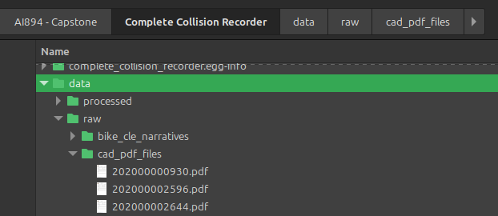(Figure 6.1 - screenshot of directory CAD files are saved to)

* + 1. Police officer narratives are not available in the structured GCAT data as these narratives sometimes contain contact and personal information of victims. Therefore, ODOT does not compile these free-text narratives for common use. However, because this project is primarily focused on NLP narratives the narrative box is highly desired from these reports. To extract it from the PDF images, a pre-defined template is used to approximate locations of boxes and an algorithm is directed to crop the extracted image to only the narrative box.

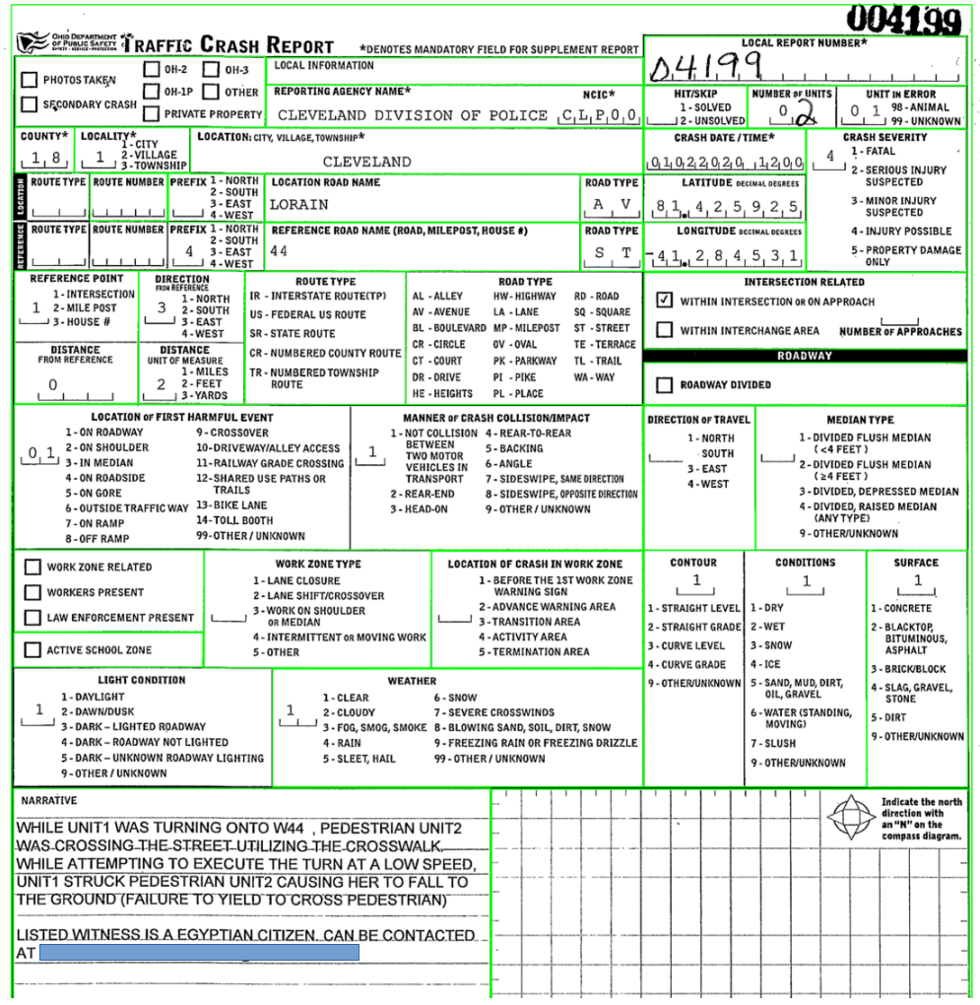

(Figure 6.2 - Full first page of OH1 with bounding template bounding boxes aligned to form)

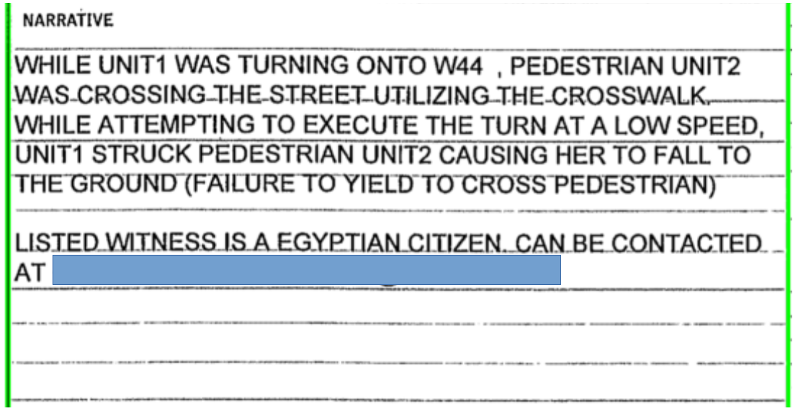

(Figure 6.3 - Image of extracted narrative box)

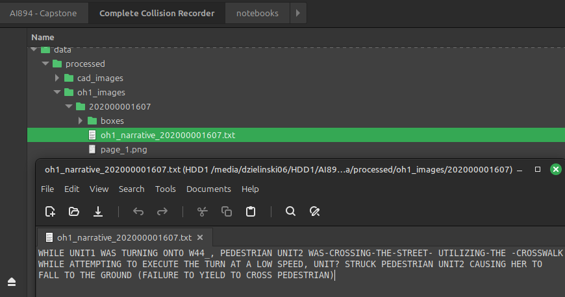

(Figure 6.4 - OCR extracted text from narrative box)

* 1. GCAT data
     1. Access to this data requires an approved login from ODOT. The download portal allows for filtering and downloading through the GCAT - Crash Data Search portal. Downloaded data is filtered to events in from the City of Cleveland Police Department since 2019. The output is delivered as a CSV file:

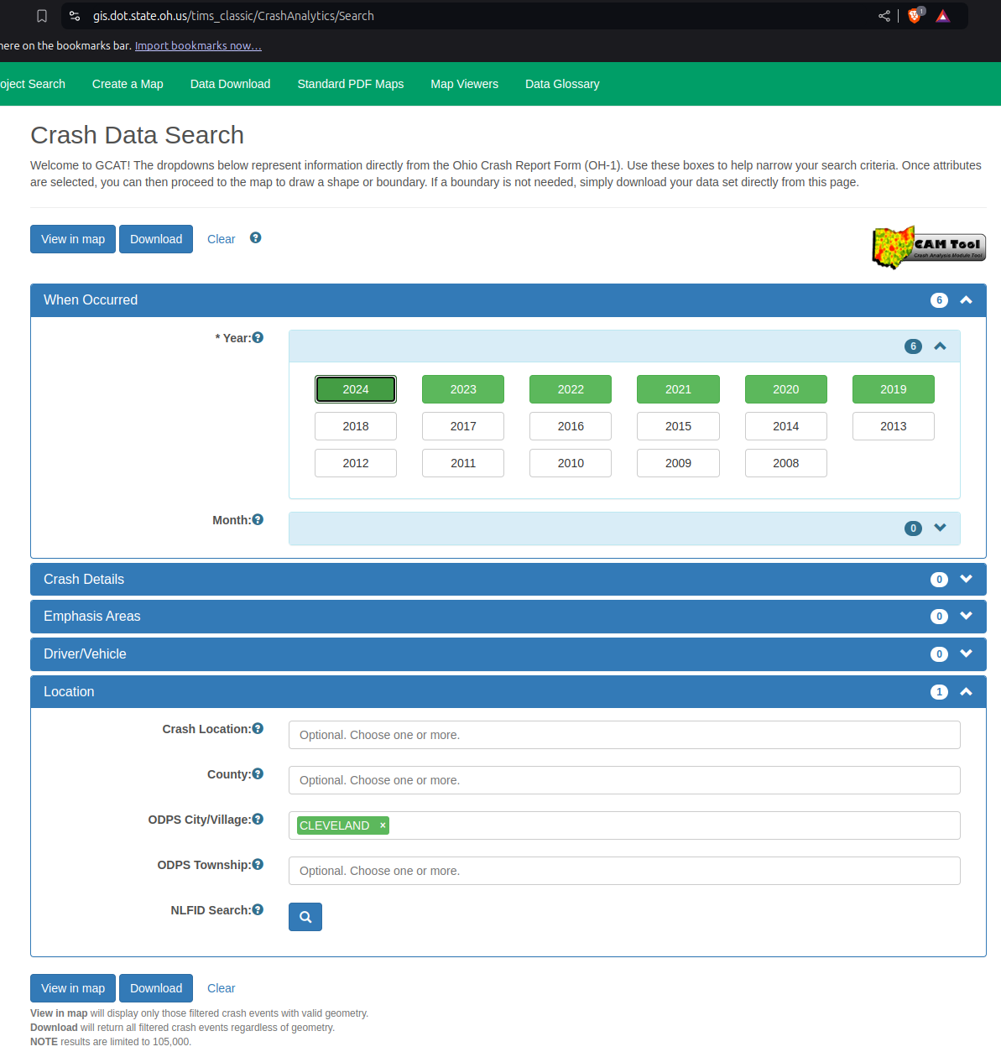

(Figure 6.5 - Screenshot of GCAT Portal)

* + 1. GCAT data has a lot of fields, most of which are not useful for this project. The field of primary interest to this project is:
       1. CRASH_SEVERITY_CD

1. **Dataset Storage**
   1. Raw files are stored in a local file/folder structure corresponding to their source and type.
   2. Raw data is processed with an OCR extraction function and text is parsed into a “processed” folder along with any images that were parsed and processed.
   3. The data is not very large but OCR extraction from images is I/O intensive and takes a while. Once the data parsed into individual .txt files, they are easily handled and imported into dataframes. One dataframe acts as a central collection point of all extracted and imported data, called **training_df** (/data/processed/training_df.csv)

**Data Dictionary of training_df –** the merged combination of CAD, OH1, GCAT, and BikeCLE labels

(Table 6.1 - Training_df data dictionary)

| Column Name | Data Type | Description | Allowed Values / Constraints | Required (Y/N) | Notes |
| --- | --- | --- | --- | --- | --- |
| CAD_ID | string | Computer Aided Dispatch (CAD) ID Number | 12 position string | Y | First four positions are indexed to the year a record was created and remaining numbers are assigned sequentially |
| CRASH_SEVERITY_CD | string | Crash Severity Code | 1 - 5 | Y | From GCAT - The most serious injury of any party: **1 - Fatal** (Death within 30 minutes of collision), **2 - Serious Injury Suspected** (Severe laceration exposing underlying tissue, broken bone, crush injury, skull or chest or abdominal injury, burns over 10% of body, unconscious when taken from scene, paralysis), **3 - Minor Injury Suspected** (Examples: lump on head, abrasions, bruises, cuts on surface of skin without exposure of deep tissue), **4 - Injury Possible** (Examples: claim of injury, limping, complaint of pain, injury indicated by behavior but not readily evident), **5 - Property Damage Only** (No reason to believe any bodily harm from collision and no physical evidence of injury) |
| INTERSECTION_IND | string | GCAT Intersection Indicator | Y, N | N | From GCAT - Derived from INTERSECTION_ID_CURRENT - If collision was in or related to an intersection the field INTERSECTION_ID_CURRENT is populated and this field is Y else this field is N |
| CAD_TEXT | string | CAD Report Text |  | N | All OCR extracted text from PDF CAD Reports |
| OH1_TEXT | string | Police Narrative from OH1 Report |  | N | OCR extracted text from the Narrative box on the OH1 crash report |
| BIKE_CLE_TEXT | string | BikeCLE generated narrative of collision |  | N | Text generated by BikeCLE volunteers after reading through CAD, OH1, and any available documentation of collision |
| U1_TYPE_OF_UNIT_CD | string | Unit 1 Type Code | 1 - 27, 99 | N | **1** - Passenger Car, **2** - Passenger Van(Minivan), **3** - SUV, 4 - Pickup, **5** - Cargo Van, **6** - Van(9 to 15 seats), **7** - Motorcycle (2 wheeled), **8** - Motorcycle (3 wheeled), **9** - Autocycle, **10** - Moped or motorized bicycle, **11** - All Terrain Vehicle (ATV), **12** - Golf Cart, **13** - Snowmobile, **14** - Single Unit Truck, **15** - Semi-Tractor, **16** - Farm Equipment, **17** - Motorhome, **18** - Limo (Livery vehicle), **19** - Bus (16+ Passenger), **20** - Other Vehicle, **21** - Heavy Equipment, **22** - Animal with Rider or Animal-Drawn Vehicle, **23** - Pedestrian / Skater, **24** - Wheelchair (Any), **25** - Other Non-Motorist, **26** - Bicycle, **27** - Train, **99** - Unknown or Hit/Skip |
| U1_TURN_CD | string | Unit 1 Turn Code | NT, LT, RT, UT | N | NT - No Turn / Straight Ahead, LT - Left Turn, RT - Right Turn, UT - U-Turn |
| U2_TYPE_OF_UNIT_CD | string | Unit 1 Type Code | 1 - 27, 99 | N | **1** - Passenger Car, **2** - Passenger Van(Minivan), **3** - SUV, 4 - Pickup, **5** - Cargo Van, **6** - Van(9 to 15 seats), **7** - Motorcycle (2 wheeled), **8** - Motorcycle (3 wheeled), **9** - Autocycle, **10** - Moped or motorized bicycle, **11** - All Terrain Vehicle (ATV), **12** - Golf Cart, **13** - Snowmobile, **14** - Single Unit Truck, **15** - Semi-Tractor, **16** - Farm Equipment, **17** - Motorhome, **18** - Limo (Livery vehicle), **19** - Bus (16+ Passenger), **20** - Other Vehicle, **21** - Heavy Equipment, **22** - Animal with Rider or Animal-Drawn Vehicle, **23** - Pedestrian / Skater, **24** - Wheelchair (Any), **25** - Other Non-Motorist, **26** - Bicycle, **27** - Train, **99** - Unknown or Hit/Skip |
| U2_TURN_CD | string | Unit 1 Turn Code | NT, LT, RT, UT | N | **NT** - No Turn / Straight Ahead, **LT** - Left Turn, **RT** - Right Turn, **UT** - U-Turn |

(Table 6.2 - Row and unique value counts from training_df)

|  |  |  |
| --- | --- | --- |
|  | **count** | **unique** |
| **CAD_ID** | 2174 | 2159 |
| **CAD_TEXT** | 2106 | 2090 |
| **OH1_TEXT** | 994 | 494 |
| **BIKE_CLE_TEXT** | 1315 | 801 |
| **CRASH_SEVERITY_CD** | 569 | NaN |

**Data Integrity Note On Event ID**: There is an outstanding data integrity issue which is preventing all the CAD records from being mappable to the GCAT data. The issue is rooted in the way reporting officers wrote and indexed the OH1 prior to 2023. The current convention is for officers to use the CAD ID to reference all reports related to a call, such as a crime report and an OH1. However, in the past, did not use this convention and appear to have used precinct-assigned numbers. In one example, the officer submitted what appears to be a desk filing number as the local report number, instead of the Cleveland Police CAD ID.

Where they should have used 202000004207 in the Local Report Number field, the officer entered 00115 instead. The dispatch CAD ID does appear on the report, but in the wrong spot, shown here:

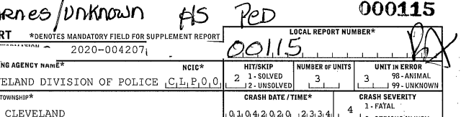(Figure 6.6 - Screenshot of OH1 report showing inconsistent report number)

This results in the GCAT data being is able to join to the OH1 PDF, and the CAD record able to join to the OH1 PDF (because it was sourced from the police), but the GCAT cannot join directly to the CAD record because GCAT is indexed differtly from CAD. This is inferred from the discrepancy above showing 994 OH1 recprds but only 569 CRASH_SEVERITY_CD values. The only possible way to correct this issue is to map GCAT to CAD by somehow joining with OH1 PDF images as a key value, which would be very unusual. Modeling can still continue with less than full data, but a comprehensive line-level comparison of individual CAD events to GCAT events is not possible at this time.

Of the data available now, modeling will focus on using the GCAT values as labels. The frequency of these values are as follows:

(Table 6.3 - Crash Severity code distribution)

|  |  |
| --- | --- |
| CRASH_SEVERITY_CD | Count |
| 1 | 13 |
| 2 | 93 |
| 3 | 229 |
| 4 | 164 |
| 5 | 70 |

(Table 6.4 - Crash Severity Derived Indicator distribution)

|  |  |
| --- | --- |
| CRASH_SEVERE_IND (Derived) | Count |
| 1 | 106 |
| 0 | 463 |

**Data Integrity Note on Crash Severity**: The severity of injuries sustained in a collision is a critical piece of information for reporting, and for decisions made from that reporting. However, there are multiple examples found in this dataset which demonstrate bias and non-objective rating of injury by officers. There are at least two examples in this dataset of a fatal injury rated by officers as ‘serious injury,’ and an unknown number of examples of serious injury rated as minor injury. Because the rating officers give an injury carries so much legal weight it must be used in this modeling. However, the problem of inconsistent officer ratings is deep. Ensuring these ratings align to an objective measure would require additional data sources, such as hospital records, and considerable human effort to validate. For now, this project will use the officer-provided injury rating as a label but will compress the detail into severe and non-severe categories. This will limit the model’s potential quality, and effectively convert the severity indicator into a review flag for follow-up by a human.

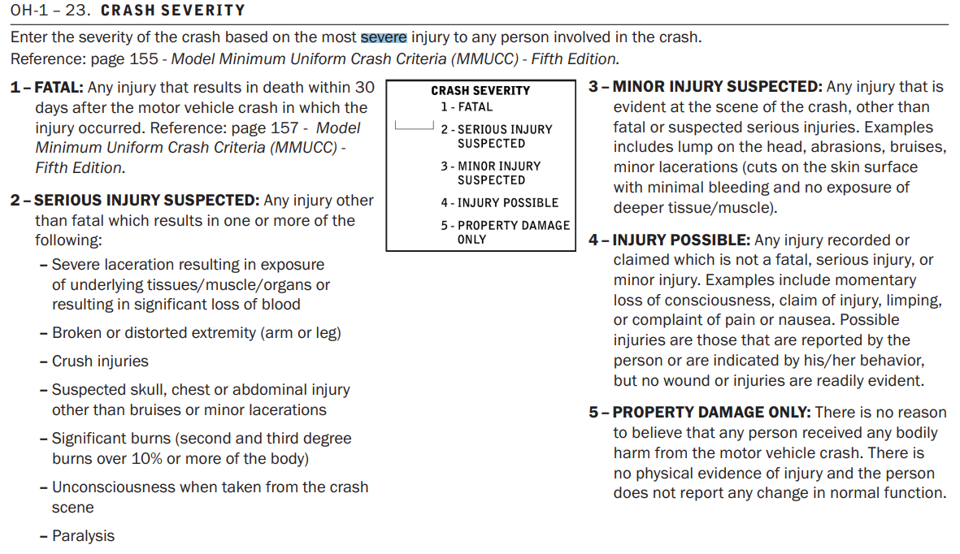(Figure 6.5a - Screenshot of User Guide with Instruction for Rating Injury Severity (ODOT, n.d.)

Once all data is collected into training_df, the CAD and OH1 text is concatenated together and tokenized with the nltk punked_tab dataset. Here are the original top 100 tokens from the combined CAD/OH1 narratives before removing unwanted text:

|  |  |  |  |  |  |  |
| --- | --- | --- | --- | --- | --- | --- |
| number: 5455 |  | em: 1396 |  | revis: 1111 |  | search: 873 |
| redact: 4968 |  | name: 1386 |  | comment: 1110 |  | adv: 869 |
| licens: 3118 |  | event: 1314 |  | r.c: 1106 |  | pm: 855 |
| accid: 2900 |  | ohio: 1308 |  | caus: 1100 |  | ave: 851 |
| vehicl: 2855 |  | use: 1279 |  | date/tim: 1097 |  | data: 788 |
| telephon: 2830 |  | address: 1272 |  | model: 1083 |  | sourc: 776 |
| and/or: 2593 |  | non: 1247 |  | disposit: 1079 |  | ml: 753 |
| victim: 2271 |  | fatal: 1245 |  | receiv: 1073 |  | person: 750 |
| motor: 2205 |  | role: 1203 |  | treatment: 1067 |  | loi: 739 |
| incid: 2192 |  | state: 1178 |  | result: 1060 |  | e: 729 |
| page: 2150 |  | make: 1147 |  | violat: 1056 |  | cross: 726 |
| crime: 2138 |  | without: 1147 |  | mm: 1053 |  | street: 706 |
| reason: 2011 |  | applic: 1144 |  | aircraft: 1053 |  | polic: 653 |
| type: 1991 |  | file: 1144 |  | boat: 1053 |  | assign: 650 |
| struck: 1879 |  | creat: 1141 |  | trolley: 1053 |  | prioriti: 633 |
| cleveland: 1832 |  | purchas: 1141 |  | misdemeanor: 1053 |  | id: 608 |
| call: 1745 |  | novapdf: 1140 |  | higher: 1053 |  | dob: 608 |
| pursuant: 1740 |  | pdf: 1140 |  | log: 1009 |  | public: 605 |
| unit: 1719 |  | gener: 1137 |  | complet: 995 |  | handl: 595 |
| report: 1708 |  | injuri: 1130 |  | caller: 986 |  | color: 575 |
| document: 1699 |  | wit: 1128 |  | count: 953 |  | case: 574 |
| code: 1695 |  | parti: 1127 |  | st: 941 |  | statu: 568 |
| descript: 1571 |  | notic: 1126 |  | veh: 938 |  | devic: 566 |
| date: 1569 |  | phone: 1120 |  | pedestrian: 915 |  | divis: 565 |
| medic: 1546 |  | system: 1119 |  | locat: 882 |  | hazard: 561 |

Some of these words are clearly from the boilerplate verbiage that come with any public records request. To clean and remove unwanted text, regular expressions are used to remove redaction logs (aka footers) and typical header information from CAD files using the process_ocr method in the PdfTextExtraction class. The *process_ocr* method:

1. Extracts text with Tesseract OCR
2. Removes unwanted text strings, patterns, and special characters
3. Collapses multiple spaces and invisible characters into a single space
4. Converts text to upper case
5. Removes individuals’ names
6. Returns a single string

# Data Preprocessing, Building, Training, and Testing

There are two AI models included in this project. The first will be NLP categorization model and will be called the “**GCAT Model.**” This model will predict categorization fields found in the GIS Crash Analysis Tool (GCAT) data using free text narratives from 911 dispatchers and responding officers. The GCAT model will intentionally be simple with the purpose of maintaining explainability as much as possible. The second model will be called “**The BikeCLE Narrative Model**.” The BikeCLE narrative model will use concatenated text input from dispatcher and police reports, and output labels from the GCAT Model. This input will be used as a prompt to fine-tune Google’s Gemini 1.5 Large Language Model (LLM). The final output will be text generated in the style of BikeCLE volunteer reviewers summarizing each collision in roughly two to three sentences.

GCAT Model Intention:

* This model is intentionally simple in order to produce a structured output in a layout compatible with existing GIS Crash Analysis Tool (GCAT) data. The use of a blackbox model, such as a neural network or LLM, for this purpose would decrease explainability and reduce the probability this data could be incorporated into a traffic engineering process.
* LOCATION: **/notebooks/train_GCAT_severity.ipynb**

GCAT Raw data preparation

* Raw text from CAD and OH1 reports
* Remove unwanted and boilerplate text from dispatcher and officer reports
  1. This will help narrow the total vocabulary and reduce noise introduced into to document-term matrix
* Filter to records with the desired label values
  1. Of the 2,174 records in the traing_df dataset, which contains all records with either a dispatcher report or a police report, only 569 have a police report that successfully mapped to the dispatcher record ID and are trainable to the GCAT model.
* Train/Test Split
  1. Using the train_test_split class from the sklearn.model selection library, the data is split with an 80% train : 20% test ratio. The training dataset is used as input to the GCAT model to prevent data leakage from the test data into the model.

GCAT Model Input and Preprocessing:

* Stem with Porter Stemmer from NLTK
  1. The Porter stemmer is a simple and widely used word stemming technique that functions better than more elaborate techniques. It treats complex suffixes as compounds made up of simple suffixes and removes the simple suffixes in a series of steps (Porter, 1980)
* Remove stop words using NLTK corpus
  1. The NLTK stopwords corpus was generated using a corpus published in Porter, et al. (Bird, et al. 2010)
* Vectorize with Term Frequency by the Inverse Document Frequency (TFIDF) from the NLTK library
  1. This method of vectorization is the most common vectorization in current digital libraries (Kamath, 2019) and is appealing for this model because of its simplicity.
     1. Parameters to evaluate:
        1. Normalization
           1. Normalization required to counter act over or under impact of certain words on the vector
           2. This is NLP text data so features are likely to be sparse
           3. L1 (Lasso) - Reduces feature weights that are close to zero to zero and will likely result in only a few features having non-zero weight. This regularization would produce a simpler and more interpretable model.
           4. L2 (Ridge) – The sum of squares of all features weights - could be a problem if the frequency of pertinent words is an important indicator of the label. Also, it could be a problem if outliers exist in the data.
           5. **Discussion**: L1 is appealing here for its simplicity and interpretability. Initial evaluation of L1 vs L2 on a model before grid search, it appears LinearSVC is less affected by the type of normalization than Random Forest and performs similarly with either. Random Forest models, however, are more sensitive to this diffference. Under L1, Random Forests are overly conservative and require additional class balancing, presumably because of outliers. See table 6.1.
        2. Min/Max Document Frequency Limitation
           1. To remove terms that occur very frequently or very rarely, and likely not useful to this mode, the min_df and max_df parameters of the TfidfVectorizer will be used to remove these terms from the vector.
           2. **Discussion**: The removal of terms that occur in less than 5% or more than 90% of documents is chosen as a default. Adjustments to these numbers didn’t produce major differences, but not using this filter resulted in a larger document-term matrix which could overly complicate the model.
        3. Max Feature Limitation
           1. To limit the number of features and avoid the curse of dimensionality, this option will cap the maximum number of features.
           2. **Discussion**: 1000 features is a typical limit but, in this case, because the data is small and narrow in subject a lower limit may be appropriate. As a matter of first impression, 500 will be used as a max number of features until more modeling can be done.
        4. Vocabulary
           1. **Opinion**: It may be necessary to create and impose an explicit vocabulary, but that doesn’t seem necessary on first impression.

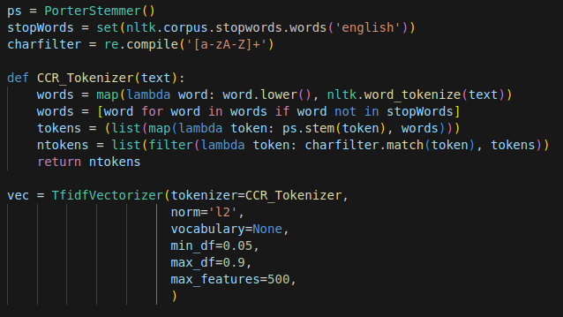

(Figure 6.7 - Code used to tokenize text)

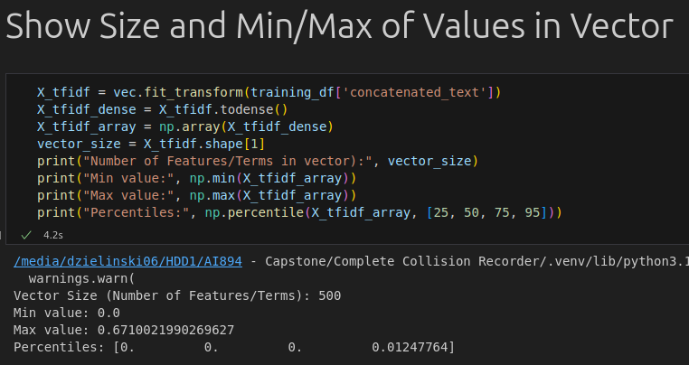

(Figure 6.8 - Evaluation of vectorized text)

**Discussion**: Figure 6.2 shows percentile values of p25, p50, and p75 all equal to zero. suggesting the data is sparse. Further, the maximum value of 0.671 suggests there is not a problematic outlier using L1 normalization and **clipping or scaling are likely unnecessary.**

* Label class imbalance correction on vectorized data
  1. To mitigate problems caused by class imbalance there are two common methods considered here: 1) undersample the majority class, or 2) oversample the minority class. Because the dataset is so small, undersampling is immediately removed from consideration in the GCAT model. Therefore, oversampling is the anticipated technique. The essence of oversampling a minority class is to select observations from the minority class and resample them until an acceptable proportion is reached between the minority and majority class. This is meant to expose a model to the characteristics of the minority class as often as it is exposed to the majority class thus increasing the classifier’s sensitivity to the minority class and reduce bias toward the majority class. There are several methods available from the *imblearn* library to perform over-selection of the minority class (Imbalanced Learn, n.d.). Methods considered for this model are discussed here:
     1. RandomOverSampler – Resamples observations from the minority class at random until equal representation between the minority and majority classes is reached.
     2. SMOTE (Synthetic Minority Over-sampling Technique) - Initially described by Chawla, et al, in 2002, this method is a combination of over-sampling the the minority class and under-sampling the majority class to achieve better AUC and ROC performance compared with under-sampling alone or adjusting the loss ratios or class priors (Chawla, et al., 2002).
     3. ADASYN (ADAptive SYNthetic oversampling) - Similar to SMOTE, but the sampling ratio is weighted based on the difficulty to learn the class (He, 2008).
     4. SVMSMOTE (Support Vector Machine for Synthetic Minority Over-sampling Technique) - This method creates an artificial minority instance that either extrapolates or interpolates the minority class based on the presence of the majority class (Nguyen, 2011).

**GCAT Model Discussion**: The dataset is small so an undersampling-only technique is avoided. A random over-sampling technique is the simplest method, and appealing for that reason. However, a comparison of all sampling techniques was performed with code seen in Firgure 6.3 and output shown in Figure 6.1 suggests class imbalance correction may not be necessary. The highest F1 of the initial modeling came from the Linear SVC. The second highest F1 came from a Linear SVC with SVMSMOTE class balancing technique – both with L2 normalization. The main candidates for exploration are either no class imbalance correction or SVMSMOTE correction.

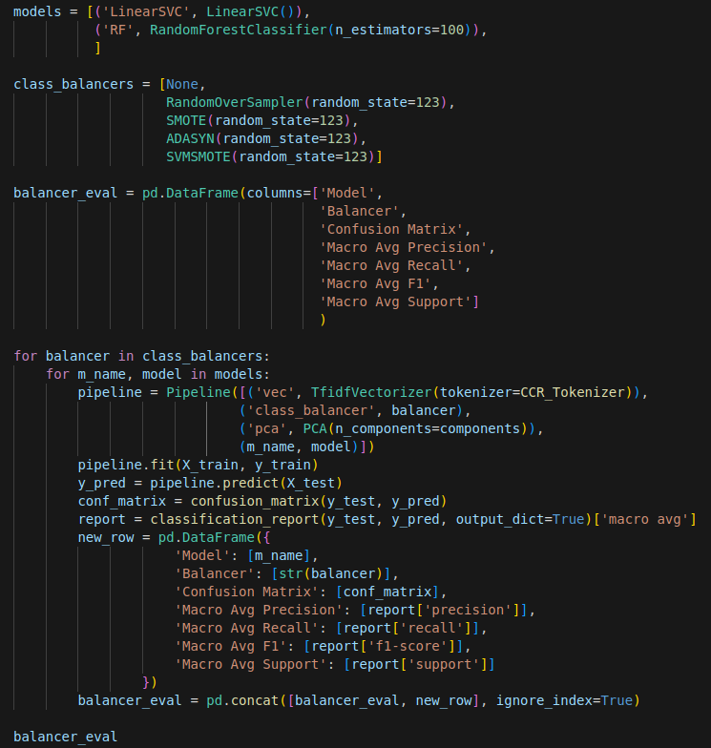

(Figure 6.9 - Code used to evaluate potential candidates for class balancing technique)

|  |  |  |  |  |  |  |
| --- | --- | --- | --- | --- | --- | --- |
| **Normalization** | **Model** | **Balancer** | **Confusion Matrix** | **Macro Avg Precision** | **Macro Avg Recall** | **Macro Avg F1** |
| L2 | LinearSVC | None | [[89, 2], [14, 9]] | 0.841 | 0.685 | 0.723 |
| L2 | RF | None | [[91, 0], [23, 0]] | 0.399 | 0.500 | 0.444 |
| L2 | LinearSVC | RandomOverSampler | [[68, 23], [9, 14]] | 0.631 | 0.678 | 0.638 |
| L2 | RF | RandomOverSampler | [[91, 0], [23, 0]] | 0.399 | 0.500 | 0.444 |
| L2 | LinearSVC | SMOTE | [[70, 21], [10, 13]] | 0.629 | 0.667 | 0.637 |
| L2 | RF | SMOTE | [[85, 6], [20, 3]] | 0.571 | 0.532 | 0.527 |
| L2 | LinearSVC | ADASYN | [[72, 19], [10, 13]] | 0.642 | 0.678 | 0.653 |
| L2 | RF | ADASYN | [[84, 7], [19, 4]] | 0.590 | 0.548 | 0.551 |
| L2 | LinearSVC | SVMSMOTE | [[83, 8], [12, 11]] | 0.726 | 0.695 | 0.708 |
| L2 | RF | SVMSMOTE | [[88, 3], [19, 4]] | 0.697 | 0.570 | 0.578 |
|  |  |  |  |  |  |  |
| L1 | LinearSVC | None | [[87, 4], [16, 7]] | 0.741 | 0.630 | 0.654 |
| L1 | RF | None | [[91, 0], [23, 0]] | 0.399 | 0.500 | 0.444 |
| L1 | LinearSVC | RandomOverSampler | [[81, 10], [14, 9]] | 0.663 | 0.641 | 0.650 |
| L1 | RF | RandomOverSampler | [[91, 0], [22, 1]] | 0.903 | 0.522 | 0.488 |
| L1 | LinearSVC | SMOTE | [[83, 8], [16, 7]] | 0.653 | 0.608 | 0.621 |
| L1 | RF | SMOTE | [[79, 12], [18, 5]] | 0.554 | 0.543 | 0.545 |
| L1 | LinearSVC | ADASYN | [[81, 10], [16, 7]] | 0.623 | 0.597 | 0.606 |
| L1 | RF | ADASYN | [[75, 16], [17, 6]] | 0.544 | 0.543 | 0.543 |
| L1 | LinearSVC | SVMSMOTE | [[87, 4], [16, 7]] | 0.741 | 0.630 | 0.654 |
| L1 | RF | SVMSMOTE | [[87, 4], [19, 4]] | 0.660 | 0.565 | 0.571 |
|  |  |  |  |  |  |  |
| L1 minus L2 | LinearSVC | None |  | -0.101 | -0.054 | -0.069 |
| L1 minus L2 | RF | None |  | 0.000 | 0.000 | 0.000 |
| L1 minus L2 | LinearSVC | RandomOverSampler |  | 0.032 | -0.037 | 0.012 |
| L1 minus L2 | RF | RandomOverSampler |  | 0.504 | 0.022 | 0.044 |
| L1 minus L2 | LinearSVC | SMOTE |  | 0.024 | -0.059 | -0.016 |
| L1 minus L2 | RF | SMOTE |  | -0.017 | 0.011 | 0.018 |
| L1 minus L2 | LinearSVC | ADASYN |  | -0.019 | -0.081 | -0.047 |
| L1 minus L2 | RF | ADASYN |  | -0.046 | -0.006 | -0.007 |
| L1 minus L2 | LinearSVC | SVMSMOTE |  | 0.014 | -0.065 | -0.054 |
| L1 minus L2 | RF | SVMSMOTE |  | -0.037 | -0.005 | -0.007 |

(Table 6.5 - Preliminary comparison of model performance before grid search comparing L1/L2 normalization and class imbalance correction techniques)

* Variable reduction and embedding creation
  1. Adopting a rule of thumb that 95% of variance should be retained in PCA components (baeldung, 2024), initial modeling generally returns a little less than 200 components, depending on the seed value.

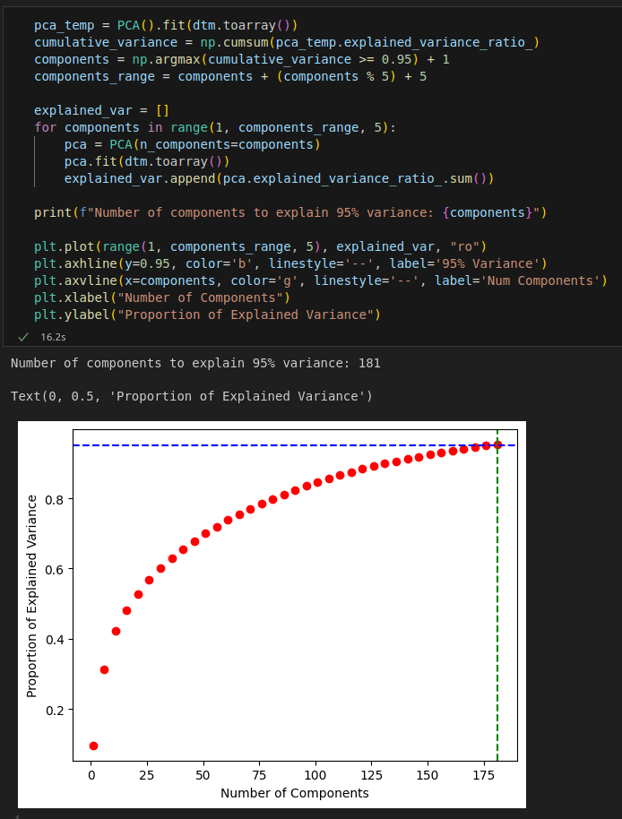

(Figure 6.10 - Selection of the number of components for PCA variable reduction/embedding)

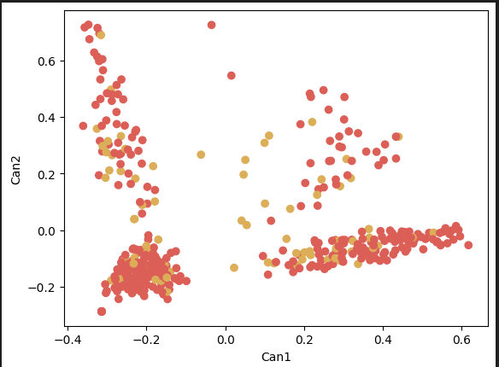

(Figure 6.11 - Scatter plot of vector with Severity Score highlighting)

* Consolidating GCAT Preprocessing
  + All preprocessing steps and evaluation described here will be contained within a Class object in the complete_collision.py library, available in the PreprocessGCAT class object. (*/src/complete_collision_recorder/complete_collision.py*)
  + This class will have these methods:
    - CCR_Tokenizer
    - fit_and_evaluate_tfidf_vector
    - create_doc_term_matrix
    - pca_analysis
    - evaluate_balancers

GCAT Model Pipeline:

* Using the pipeline class from the imblearn library, a model pipeline is constructed for each label being predicted.
  + This model is created in a Jupyter Notebook stored in */notebooks/train_GCAT_severity.ipynb*
* GridSearch – Using the GridSearchCV from the sklearn library, each pipeline will be searched for the best combination of Regularization and Loss parameters for a LinearSVC model.
  + 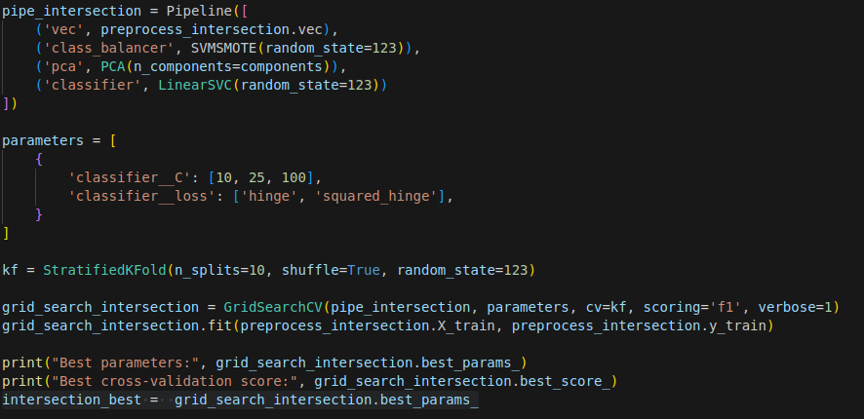 (Figure 6.12 - GridSearch example of GCAT Model Pipeline for Intersection Label)

GCAT Model Output Assembly:

* The output of the GCAT model output will contain:
  + Concatenated text from:
    - Dispatcher
    - Officer
    - GCAT Model-developed descriptors
  + See Figure 6.7 for code sample to combine GCAT output with raw text inputs

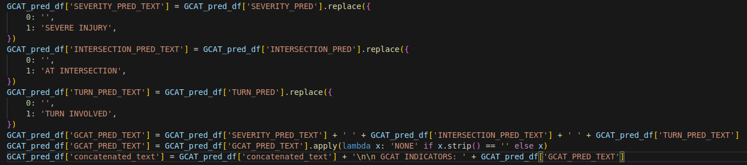 (Figure 6.13 - Concatenation of GCAT Model output with raw text input)

* This concatenated text will become the feature text that is input into the *BikeCLE Narrative Model*

GCAT Model Validation

* Split data using an 80% train -to- 20% test ratio for validation using the Scikit-learn library
* Will use StratifiedKFold cross-validation 10 splits and shuffle enabled on the training dataset
  + **Discussion**: Using only a K-Folds cross validation is appealing because the data is small. However, the importance of ensuring the model does not overfit and generalizes well is a high interest to this model. For this reason, using both splitting and cross-validating is the initial modeling attempt.
* This model maximizes F1 scores for each of the predicted labels using a GridSearchCV from the scikit-learn library.
* Evaluation of prediction labels

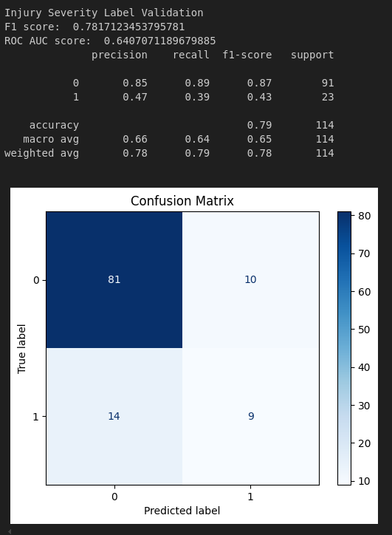

* + (Figure 6.14 - Validation report of Injury Severity label from GCAT model)
* **Discussion**: The performance of the severity prediction is not very good at identifying severe injury when a severe injury is present. While this prediction seems to error on the side of a conservative indication, which is a somewhat good thing from a subject matter standpoint, it is not great from a modeling standpoint. It is likely t poor performance here might be related to inconsistent rating from responding officers – see figure 6.5a. and related data integrity note.

BikeCLE Narrative Model Intention:

* This model is intended to mimic the natural language summary of volunteers who have reviewed narrative text and documentation from dispatcher and police reports. This output is meant to summarize individual collisions and to declutter the sometimes long and inconsistent narratives produced from dispatch and officer narratives. It is not intended to produce structured output. The use of an LLM is expected to introduce a black box into the overall project, and thus reduce explainability, with the expectation the LLM will be a stronger model than the GCAT Model and will make subsequent human quicker and easier. The input of this model will be the same raw text used for the GCAT model, but with additional text that was output from the GCAT model. The output will be a short, two to three sentence summary describing key points of interest of the collision.
* LOCATION: **/notebooks/train_and_evaluate_bikeCLE_Gemini.ipynb**

BikeCLE Narrative Model Input and Preprocessing

* This model will be a fine-tuning of Google’s *Gemini 1.5 Flash 001 Tuning*.
* Stemming and tokenization use proprietary tools behind Google’s firewall and will be handled entirely within the low-code Google AI Studio. The development studio will be trained using input/output text pairs and the output will generally be one to three sentences summarizing the input text.
  1. Internally, Gemini employs “subword tokenization.” This technique is described in a Google Research post, which describes how the algorithm divides words into subunits, such as morphemes or individual characters and retains semantic meaning while providing flexibility to rare or unknown words (Song, Zhou, 2021).
* Development will follow guidance from Google’s Fine-tuning tutorial (Fine-tuning tutorial, 2024), published here: <https://ai.google.dev/gemini-api/docs/model-tuning/tutorial?lang=python>

BikeCLE Narrative Model

* + Built here: <https://aistudio.google.com/tune>
  + 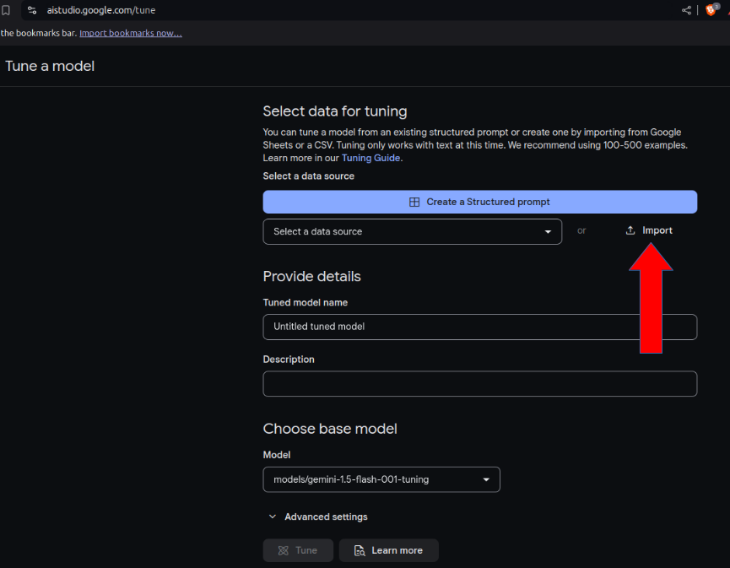

(Figure 6.15 - Load data into Gemini)

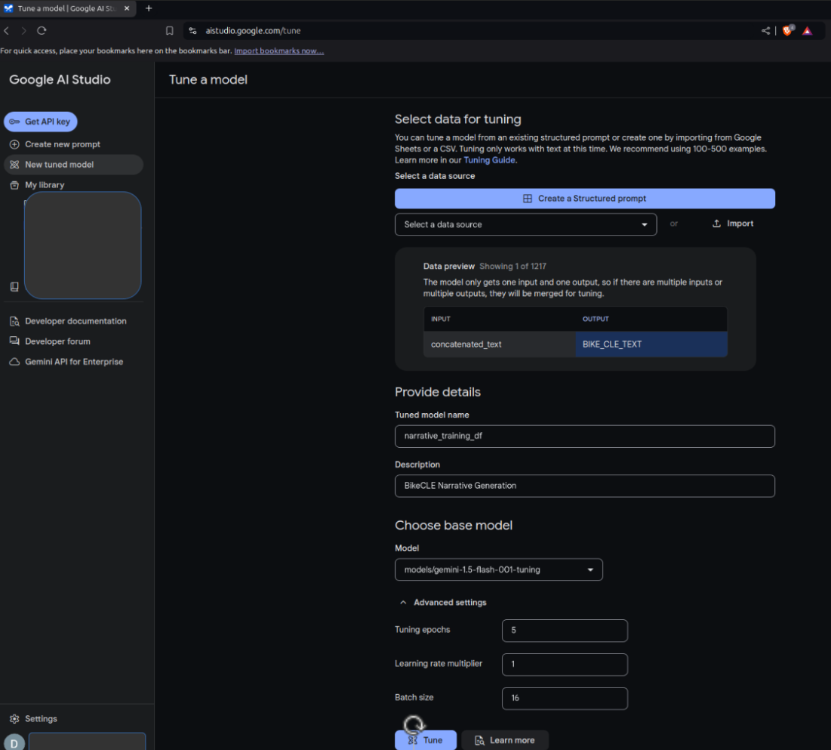

(Figure 6.16 - Define input and output text in Gemini)

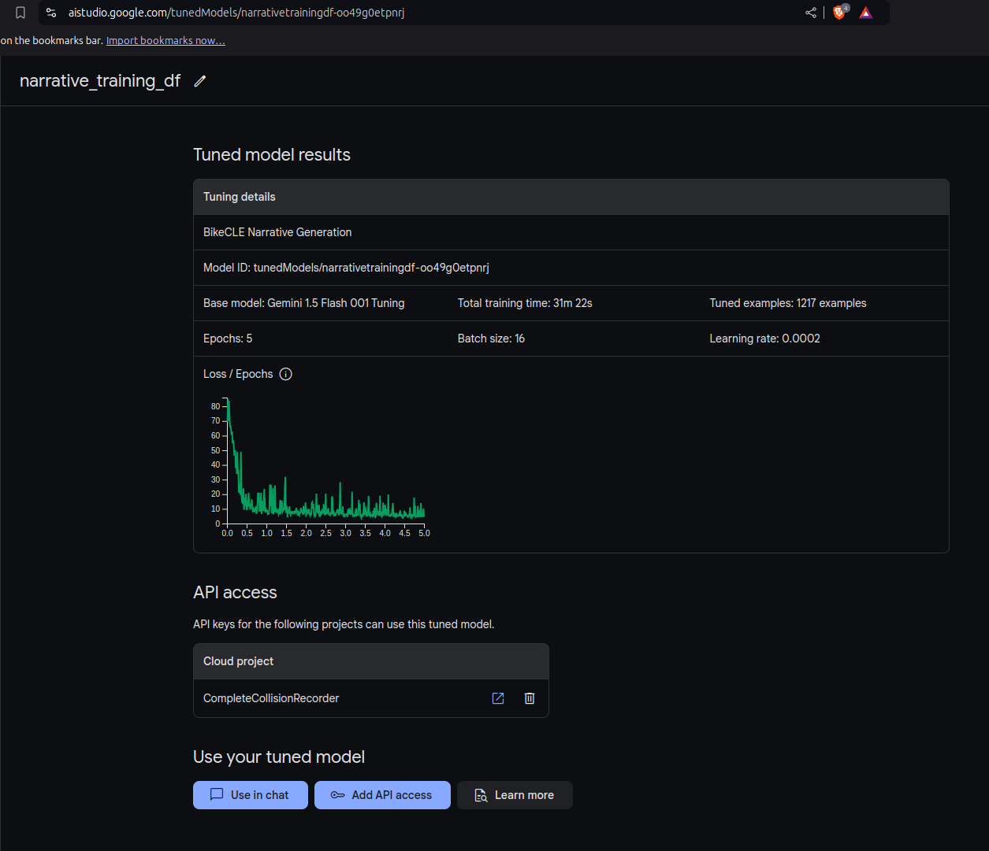

(Figure 6.17 - Train and show results in Gemini)

* + The pre-tained model chosen as the basis of fine-tuning is Gemini 1.5 Flash 001 Tuning. The architecture of this model is not disclosed by Google, but it is part of Google’s DeepMind project and utilizes a series of common neural network techniques, such as transformers, an attention mechanism, and backpropogation (Shahine, 2024).
* Example BikeCLE Narrative prompt text:

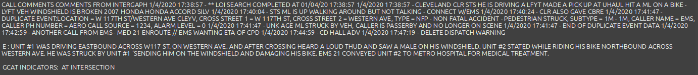

* Example BikeCLE Narrative label text:



BikeCLE Narrative Model Validation

Because the LLM output is an emulation of human judgment, human judgment is used in this project to score the output for consistency with the original label provided by Bike Cleveland. Review was performed on two dimensions. The first was to verify the output provided a sufficient summary and did not inject an unacceptable hallucination. The second was the validate the use of terms indicating a severe injury.

Narrative accuracy was scored at 92%:

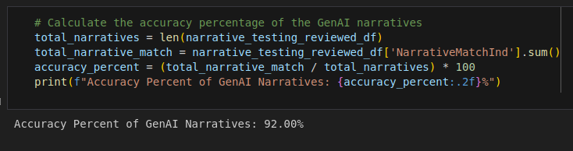

(Figure 6.18 - Code snippet of GenAI narrative accuracy)

And, severe injury term usage reached an F1 score of 0.95. It is noted that the GenAI model’s use of sever injury terms performs better than the GCAT model alone.

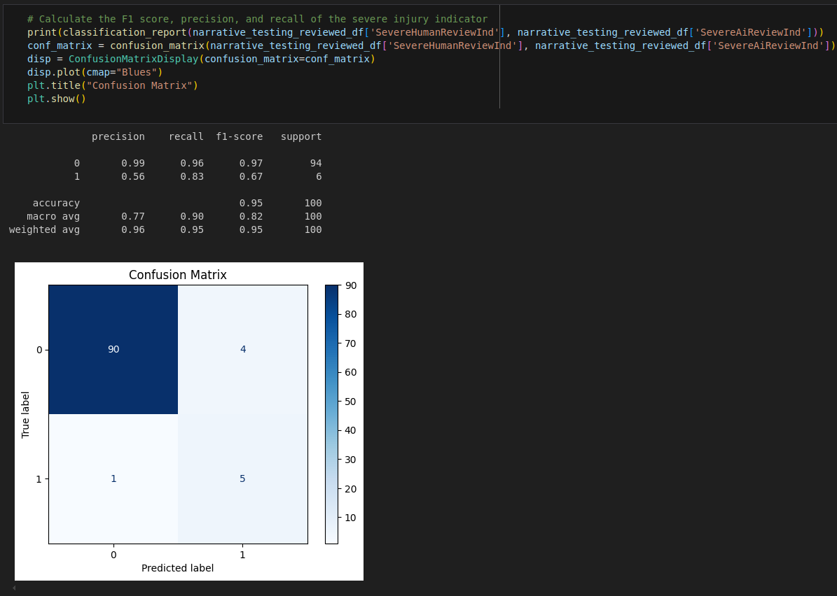

(Figure 6.19 - F1 score of BikeCLE Narrative Model)

**Citations**

# Model Deployment and ContINual Learning

When new data is received by the process, it will go through a series of steps to be extracted, cleaned, and scored by the process (illustrated in Figure 12.1). These steps are a combination of human-driven and codified processes. This section describes how the manual, human-driven processes interact with the codified processes and describes how a simple Graphical User Interface (GUI) can assist running the code.

**Deployed Model Files**

This project has two models, GCAT and BikeCLE narrative generation. The GCAT model is deployed into a pickle file and is saved to /models/severity.pkl. This is a local binary file and is easily moved and used to score new data.

The BikeCLE narrative model is not local and relies on a connection to Google’s Gemini AI service. Use of this service requires an API key. Scoring a local dataset outside of Google’s AI Studio requires the use of the google.generativeai library and the API key to be stored in the .env file of the Python root folder.

These two models support the reception of new data as shown in Figure 12.1 with the dotted lines supporting the ‘score_and_describe_reports.py’ program.

**New Data Reception**

When new data is received it is processed through a series of steps. These steps do not necessarily need to be run in order, but the requisite data must be in place for each step to run successfully. High-level steps:

* **Human-driven**: Periodically extract GIS Crash Analysis Tool (GCAT) data from the state web portal.
* **Human-driven**: Retrieve Computer-Aided Dispatch (CAD) reports from public records requests of the City of Cleveland
* **Human-driven**: Retrieve standardized police crash (OH1) reports via public records requests through the City of Cleveland
* **Codified**: Extract text from Computer Aided Dispatch (CAD) PDF files
* **Codified**: Extract text from standardized police report (aka OH1) PDF files
* **Codified**: Collect and assemble all text into single file
* **Codified**: Score records with “GCAT Model” and create GenAI descriptions of events using the “BikeCLE Narrative Model.”
* **Human-driven**: Review output and ensure consistent and accurate reporting

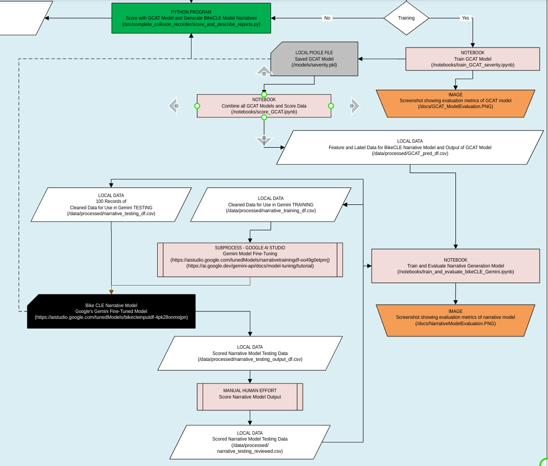(Figure 12.1 - Deployed Process flow Training Section)

A Graphical User Interface (GUI) is provided to assist with the fully codified portions of the new data process.

The app.py program collection point is integrated with a simple front-end browser-based interface running on a Flask service, which has buttons that trigger each of these programs. The interface appears like this:

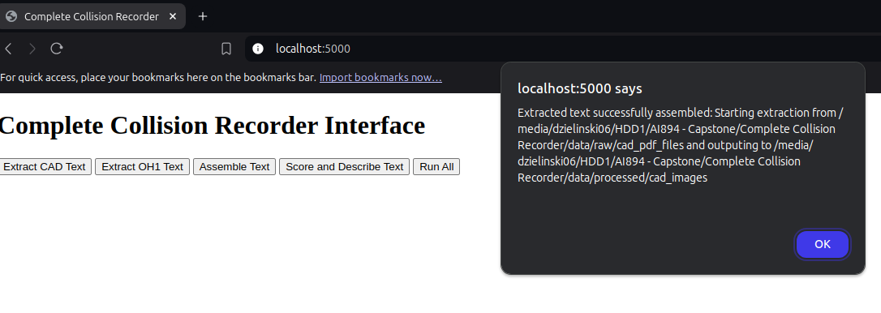

(Figure 12.2 - Screenshot of browser-based GUI to trigger process programs)

Each of the buttons shown in figure 12.2 corresponds with one of the codified programs mentioned above. The webpage is hosted locally for this demonstration using a Flask application. Pressing each of the buttons sends a GET request to the Flask service triggering specified programs to run and returns printed messages from each program. The immediate response and result of pressing each button is shown in figure 12.3 through 12.

**Extract CAD Text**

To successfully run this program, the incoming PDF files must be saved to /data/raw/cad_pdf_files with the CAD ID number as the file name, as shown in figure 12.3. Use of this button is shown in figure 12.4. The output of this program will be .txt files produced from and OCR process, which extracts and cleans text from these PDFs placed here: /data/processed/cad_images/{cad_id}cad_narrative_{cad_id}.txt

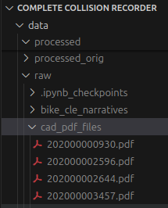 (Figure 12.3 - CAD PDF files populated in cad_pdf_files folder)

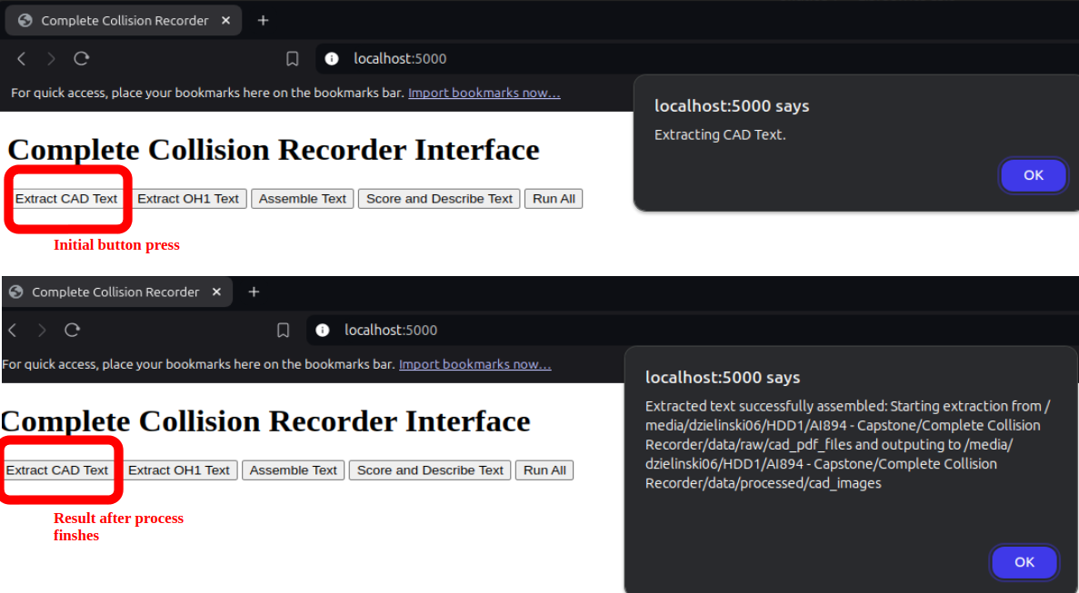

(Figure 12.4 - Interaction experience after pressing ’Extract CAD Text’ button)

**Extract OH1 Text**

For this button to work properly, OH1 reports should be saved into the oh1_pdf_files folder with the CAD ID as the file name, as shown in Figure 12.5. The usage experience is shown in Figure 12.6. The output of this program will be .txt files produced from and OCR process, which extracts and cleans text from these PDFs placed here: /data/processed/oh1_images/{cad_id}oh1_narrative_{cad_id}.txt

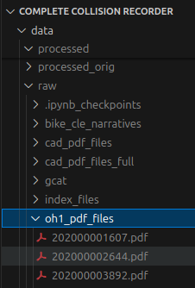(Figure 12.5 - OH1 PDF files populated in the oh1_pdf_files folder)

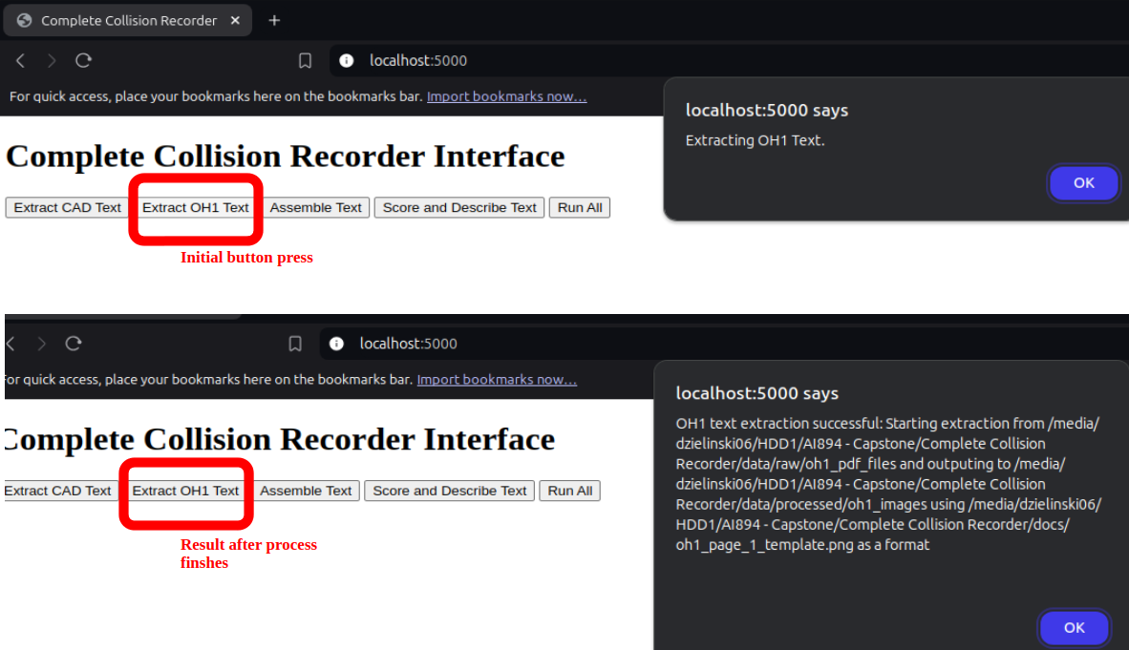

(Figure 12.6 - Interaction Experience with ’Extract OH1 Text’ button)

**Assemble Text**

For the Assemble Text button to work properly, the CAD and OH1 data must be populated in the processed data folder, and both the GCAT extract and BikeCLE narrative files must be in place, as shown in Figure 12.7. Usage experience is shown in Figure 12.8. The output of this program is training_df.csv saved in the location: /data/processed/

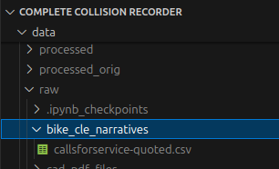

(Figure 12.7 - callsforservice_quoted.csv file shown in reference location)

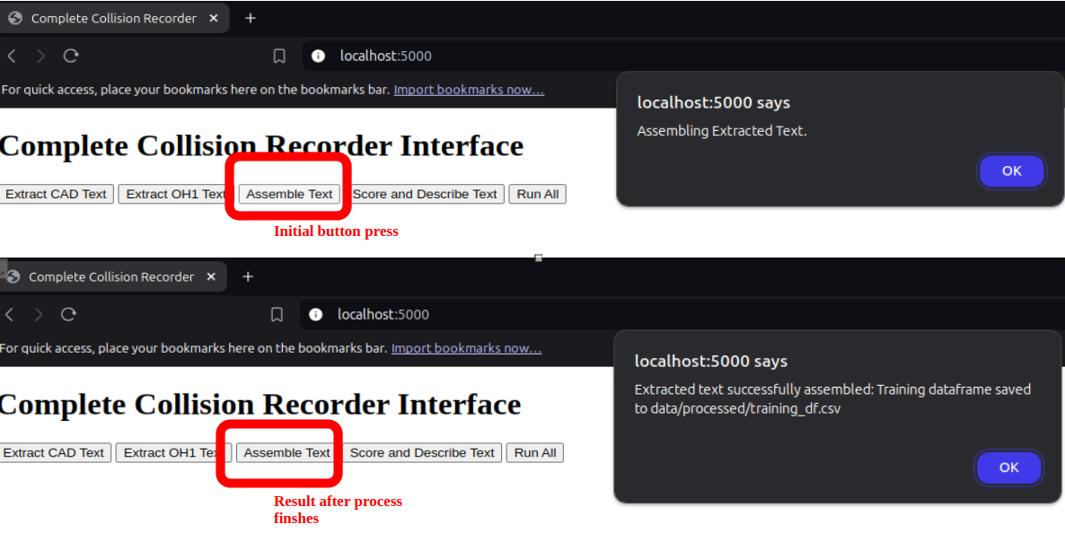

(Figure 12.8 - Interaction experience with ’Assemble Text’ button)

Score and Describe Text

This process scores the extracted OCR text with the GCAT model and generates BikeCLE – style narratives using GenAI with a fine-tuned Google Gemini model. For this process to work correctly, you must have an approved Google API key populated in the environment file (.env) saved to an alias “CCR_API,” as shown in Figure 12.9. The key must also be listed as approved in the Gemini model. The outputs of this program are GCAT_pred_text.csv and GenAI_df.csv, as shown in Figure 12.10. The user experience is shown in Figure 12.11.

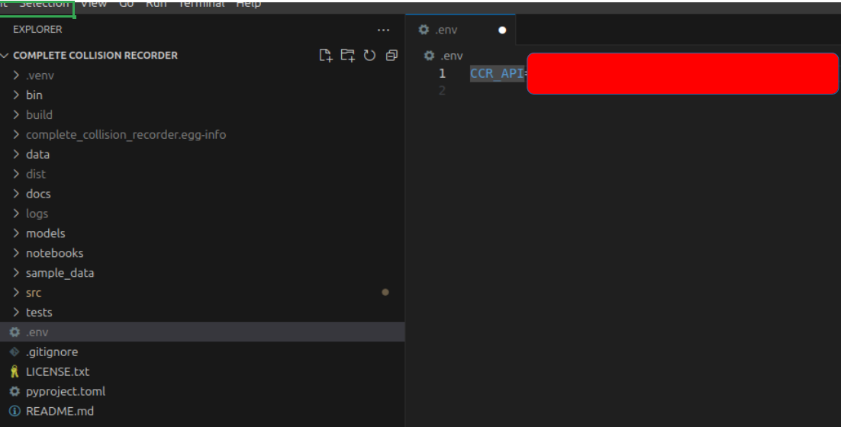 (Figure 12.9 - Populated CCR_API key)

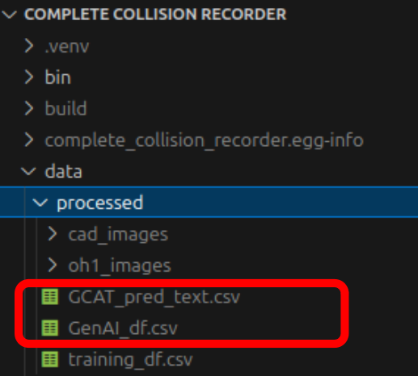 (Figure 12.10 - Output of Scoring button)

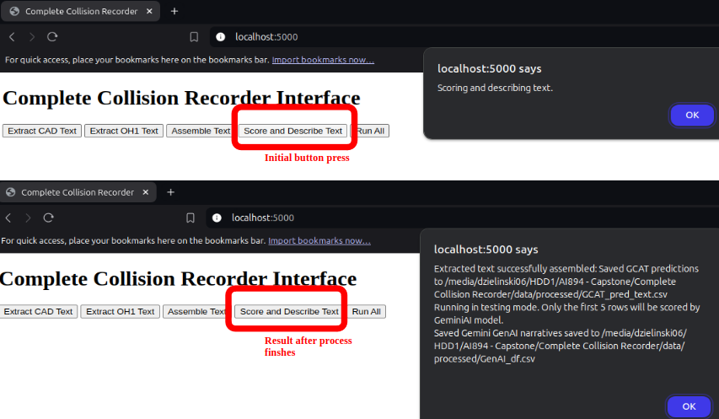

(Figure 12.11 - Interaction experience with ’Score and Describe Text’ button)

**Retraining/Model Drift Adjustments**

The BikeCle Narrative GenAI model (fine-tuned Gemini) is saved to Google’s AI Studio here: [https://aistudio.google.com/app/tunedModels/narrativetrainingdf-oo49g0etpnrj](https://aistudio.google.com/app/tunedModels/narrativetrainingdtn) . If and when this model drifts over time, updates to the weights will require periodic retraining in Google’s AI Studio. The GCAT model, however, is developed entirely within this project and stored in a binary pickle file. This will open the possibility for future functionality to be built to allow for dynamic updating of this model as it drifts over time. Until that future functionality is built, the classification model is deployed into a Jupyter Notebook saved here (/notebooks/train_and_evaluate_bikeCLE_Gemini.ipynb).

The full code with notebooks is publicly posted to GitHub here: <https://github.com/beardedDan/complete_collision_recorder>

# AI Ethics

There are two ethical concerns this model actively mitigates: privacy and transparency. Privacy considerations take the form of redacting names and personal information of parties involved in a collision and transparency is addressed by running a black-box LLM in parallel with a white-box LinearSVC model.

**Privacy**

The privacy concern is rooted in the interpretation that individuals, particularly victims, involved in documentation of vehicular collisions cannot be considered to have granted consent to having their information analyzed by this process. While a valid reason exists for extracting and collating individuals’ names and contact information, to support a BikeCLE victim support initiative, this reason is not a functional requirement of the current model. Therefore, care is taken to shield the names and personal information of individuals from collision summaries and classification predictions. The function of removing individual names from data is done in three steps:

1. Police redaction using internal process before records released publicly
2. Named Entity Recognition (NER) using SpaCy
3. Matching common first names using Social Security Administration data

**Privacy - Police Redaction**

The Cleveland Police Department (CPD), and all Ohio Police departments, are required to make public records available upon request. However, personal information is often dispersed throughout public documents. Examples of personal information in public records that is excluded under public records laws, and not considered public, is medical info, telephone numbers, and the first and last names of victims. When Computer Aided Dispatch (CAD) and OH1 records are released, the police department has a responsibility under public records laws to redact such information. This is done using a process internal to the police department before it is received by BikeCLE and it looks like this:

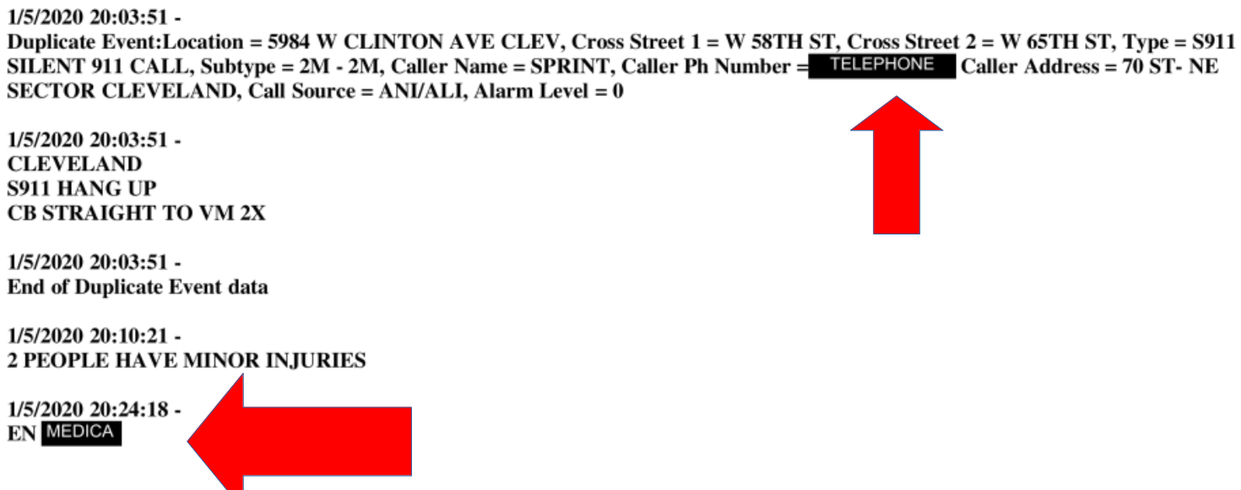

(Figure 12.12 - Screenshot of raw CAD file showing redated text for telephone and medical reasons)

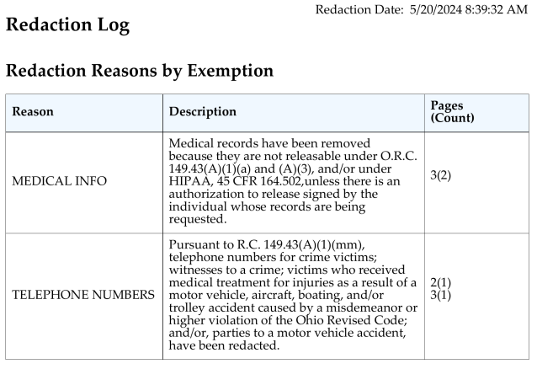

(Figure 12.13 - Screenshot of raw CAD file showing explanation of redaction and relevant statute)

It’s unclear if these redactions are the result of a purely automated process, or if done manually by humans. Extensive review of these documents reveals inconsistencies in the quality of redactions because some records still contain victim names and caller contact info. In addition, it does not appear that redaction capabilities exist at all for OH1 collision reports and sometimes victim info appears in sections of the report that it should not, such as the narrative section. As a result, even though the text data ingested into this process is publicly released, these documents still sometimes contain non-public information, and it is an ethical responsibility to perform additional steps to prevent it from being aggregated and removed it from this analysis.

**Privacy - Named Entity Recognition using SpaCy**

When a 911 call is made to report a collision, there are a several types of people that may have their information attached to the record. Some examples are: caller name, dispatcher name, police officer name, suspect/offender name, and victim name. There are legal protections to protect information about callers, victims, and uncharged suspects so their names are not be considered public record, but dispatcher, officer, and charged offender names are not. This process is not concerned with publicly available names so applying a blanket removal of any personal name is used. The first step in this process uses Named Entity Recognition (NER) functionality of the SpaCy python library (Honnibal & Montani, 2020) and references SpaCy’s “en-core-web-trf" corpus. This method uses a transformer-based pipeline to label individual words, and gruops of words, according to their type of text. SpaCy is a common state-of-the-art library that has been tested for several NLP tasks. For the relevant NER task performed in this project, spaCy has an accuracy above 89% (Explosion AI, n.d.). It's used in this project such that if spaCy labels a word(s) as “PERSON,” that word(s) is replaced with the text “REDACTED” when the text is being cleaned and imported in the OCR step. The logic appears as:

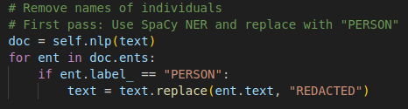

(Figure 12.14 - Screenshot of section of code showing logic to replace text using spaCy library)

**Privacy - Matching Names using Social Security Administration data**

The last pass to remove individual names is done with a simple statistical approach that does not leverage any AI or machine learning. The reason this method is important is because the raw text entered into CAD and OH1 reports is not always grammatically correct or with a typical natural cadence. Because the entry of this text is sometimes urgent, short-hand abbreviations are quite common which may create difficulty for a model, such as spaCy to detect cues from text surrounding named entities suggesting a word is a named entity. Therefore, a very simple word match, while not as powerful as spaCy in most NLP tasks, is acceptable as the last line of QA for name redaction. An example of a police internal redaction removing a phone number from a record, but failing to identify the caller’s name, is in Figure 12.15.

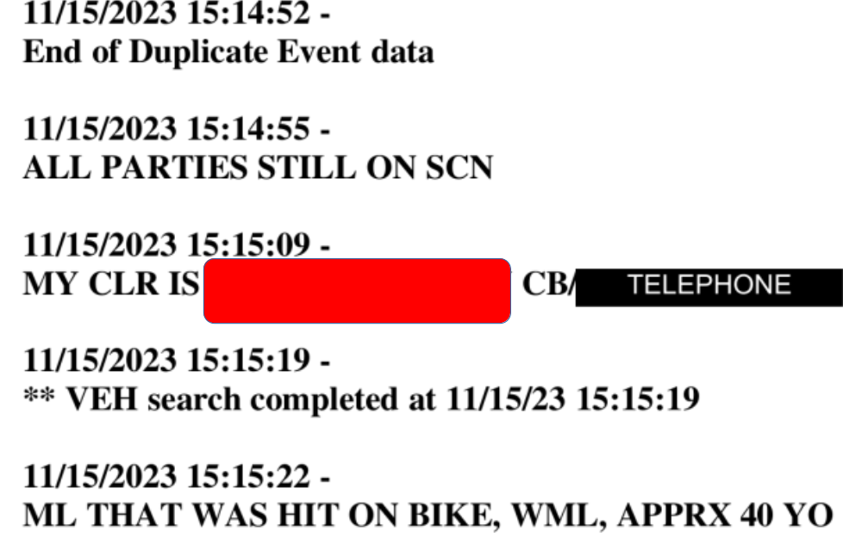

(Figure 12.15 - Screenshot showing successful police redaction of caller phone number but failure to redact caller’s name)

This method first downloads baby name data from the US Social Security Administration website (SSA, 2024), which is a webpage that has a count of occurances of baby names, of those registered with the Social Security Administration, organized by birth year going back to 1880. The process downloads, concatenates, and filters the 2000 most common baby names in the past 80 years and performs a lookup of words against that list. The application of this filter is similar to the use of spaCy and is shown in Figure 12.16.

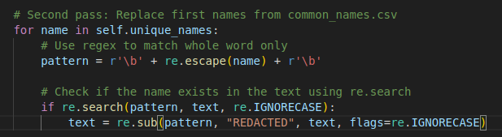

(Figure 12.16 - Screenshot of code used to perform lookup of SSA name list)

**Transparency**

One of the models in this process uses a fine-tuned version of Google’s Gemini Large Language Model (LLM), referred to in this document as the *BikeCLE Narrative Model*. The use of this model introduces a set of concerns that accompanies all LLMs in that the inner workings of the model are not interpretable by a human. In other words, it’s a black box. This has the effect of an output of the model being potentially better than that of a simpler, more interpretable model, but determining exactly why the model produced a specific output can be nearly impossible for a human to determine.

In this case, the base Gemini model is fine-tuned with input/output strings of finite length. The output is trained to be like that of BikeCLE human volunteers but, because the inner workings of the model are not transparent or controlled in a linear manner, it’s possible the model could hallucinate information or inadvertently carry through private information that would not be appropriate to include in an output. In the case of controlling private information, the prior section about privacy describes how such information is prevented from being input into training or scoring data at the beginning of the import process, reducing this concern. The issue of hallucination, or an inaccurate description is more of a concern and actively mitigated with the following methods.

Figure 12.1 shows the full deployed process flow and Figure 12.17 shows a subset of the full process flow relevant for comparing white-box and black-box output. In this flow, the BikeCLE Narrative Model is considered a black box and the output is natural language text. Despite being free text, the narrative summary can be flagged as severe/not severe based on the existence of the word “severe.” Because there would be two independent models making a prediction of severity, a comparison can be made to refer for human review when a contradiction occurs. 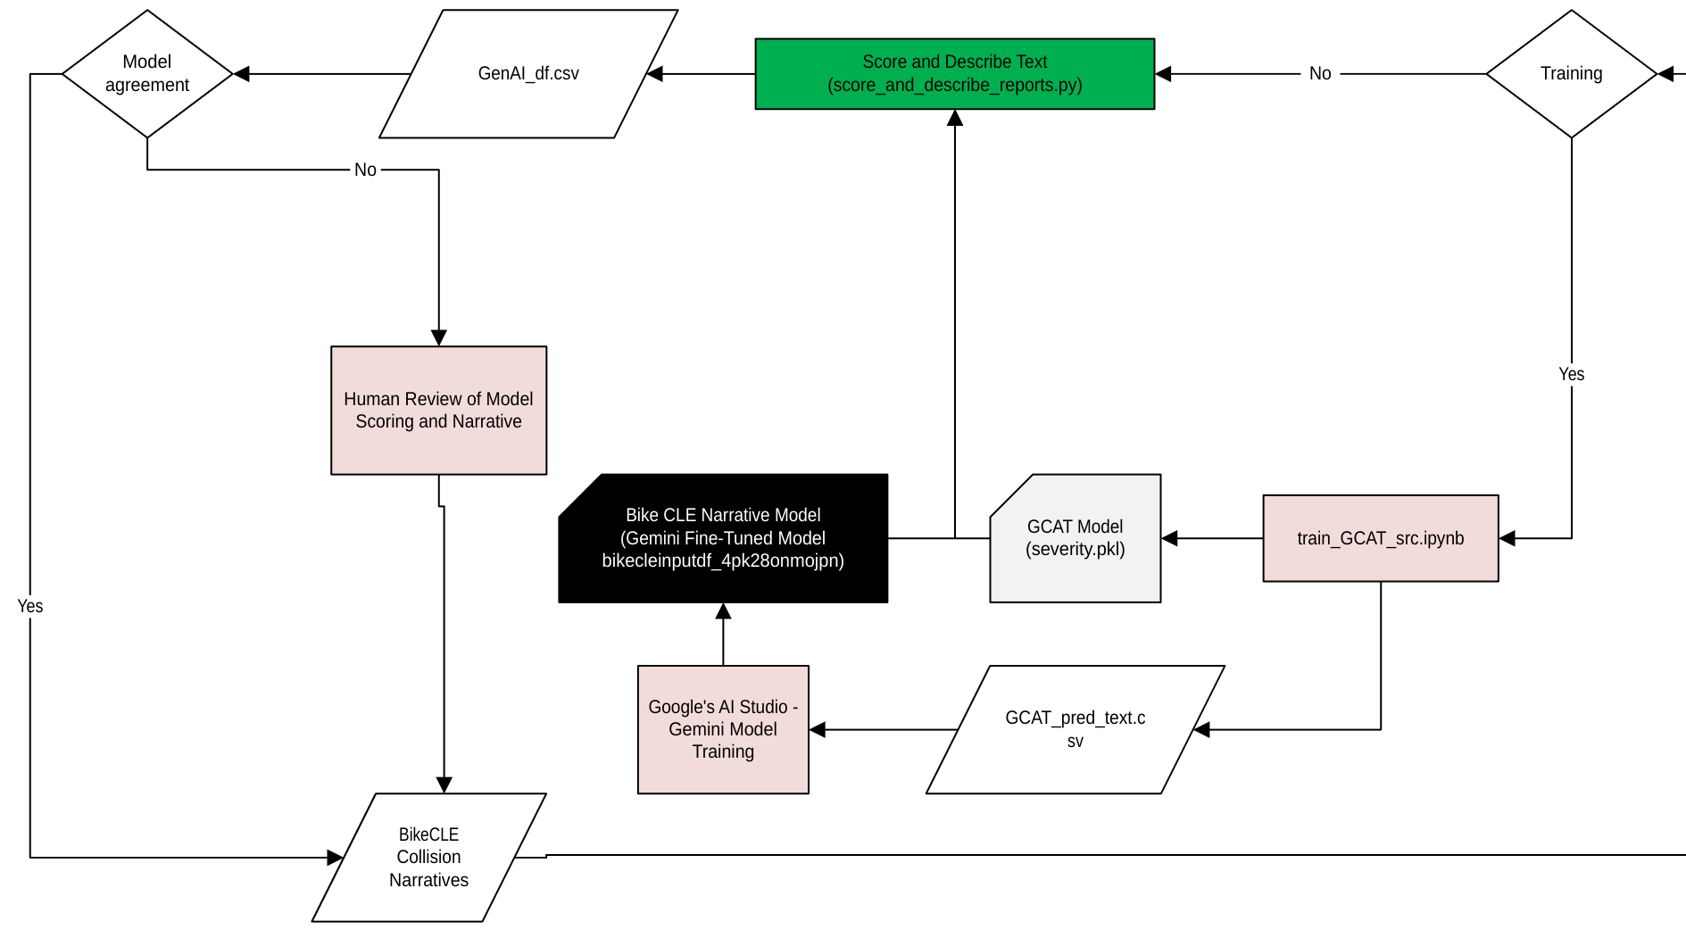(Figure 12.17 - Portion of full process flow relevant for comparing white/black box models)

An example of a disagreement between the GCAT severity prediction and the BikeCLE Narrative model is shown in Figure 12.18. In this case, the GCAT model predicts that the injury was severe (such as visibly broken bone or loss of consciousness), but the BikeCLE Narrative Model only seems to be detecting minor injury. A plain reading of this text easily demonstrates the victim was injured and transported to an Emergency Room, but the severity of the injury is not clear. It is, however, possible to parse the GCAT model (which uses a Linear SVC) and determine the amount of influence vectorized features had on the classification, shown in Figure 12.19. The most influential tokenized words in that text were “arriv, ae, dispatch, answer, and age.” The combination of features is similar enough to other records that were marked as severe that this record was also marked as severe but my interpretation of these features is the GCAT model is detecting words patterns similar to those for when the victim is a child and is transported to the ER. Those types of cases are often marked as severe regardless of the observable injuries. The OH1 in this case was not available, so it’s not possible to know for certain if the police officer classified the injury as severe, but this is a clear example of a case that a human should review.

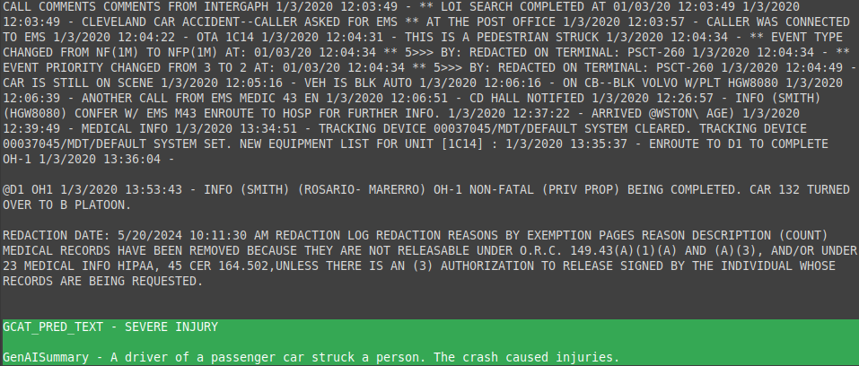(Figure 12.18 - Screenshot of raw CAD & OH1 text with GCAT Severity prediction and BikeCLE Narrative output highlighted in green demonstrating disagreement referred for human review)

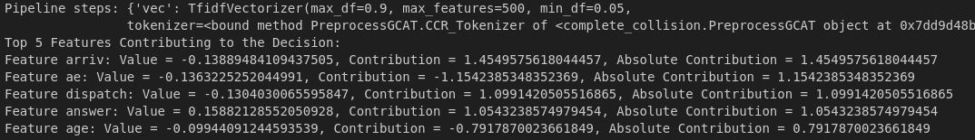(Figure 12.19 - Feature contributions to severity classification of GCAT model for text in Figure 12.18)

# PROJECT DISCUSSION AND FUTURE DEVELopment

The output of this modeling effort was intended to reduce or replace the need for human volunteers to create narratives of collisions involving pedestrians or bicyclists. While the current state of the models' output does not have a level of quality such that it may replace volunteer narrators, it does appear to offer usefulness as a screening tool for more than 90% of bike/ped collisions and will likely reduce most of the need for human narrators and facilitate scaling of the project to other cities. Summary analysis of Cleveland’s data confirms the presence of under-reporting of bike/ped collisions at rates consistent with past research. The continued collection of this data and improvement of this modeling will increase the likelihood the data will one day be used in planning decisions to correct the problem of under-reporting of bicycle and pedestrian collisions.

**Discussion**

This modeling project began with the author participating in a project to create narratives of collisions involving bicycles and pedestrians. This volunteer-led narrative creation project is a manual data collection effort led by Bike Cleveland. The approach is novel because it seeks to collect and compare police dispatch reports with police crash reports and quantify the degree of undercounting of these types of collisions. This is important because collisions which are not properly recorded cannot inform future decisions for safer streets and preventable injury becomes more difficult to prevent.

As part of Bike Cleveland’s data collection effort, this author personally reviewed over 700 dispatch and crash reports, manually creating narratives for each one. This narration effort is not only time intensive, but emotionally taxing, as the details described in some collisions might only be described as horrific, which can be difficult to read when not mentally unprepared. The aim of the current modeling project is to mitigate the human toll required to collect information about under-reported bike/ped collisions.

The output of the current modeling project is acceptable for most collision events, and can function as a screening tool for more serious events that require additional human review. This output is significant because it has the possibility to reduce workload placed on volunteers and will allow for the project to scale beyond the border of Cleveland. Indeed, a similar initiative in New York City has the aim to create the functionality described in the current project and relate collision event data across databases (Kuntzman, 2024).

This project shows that solving the issue of relating police dispatch datasets to crash dataset has the potential to solve most of the under-reporting problem. Summary statistics of the current output (figures 13.1 and 13.2) suggest rates of under-reporting similar to that documented in other research (Hauer, 1988, Abay, 2015, Ahmad, 2019). This observation suggests the data collection and processing approach taken in the current project is valid and likely a near complete representation of all bicycle and pedestrian collisions.

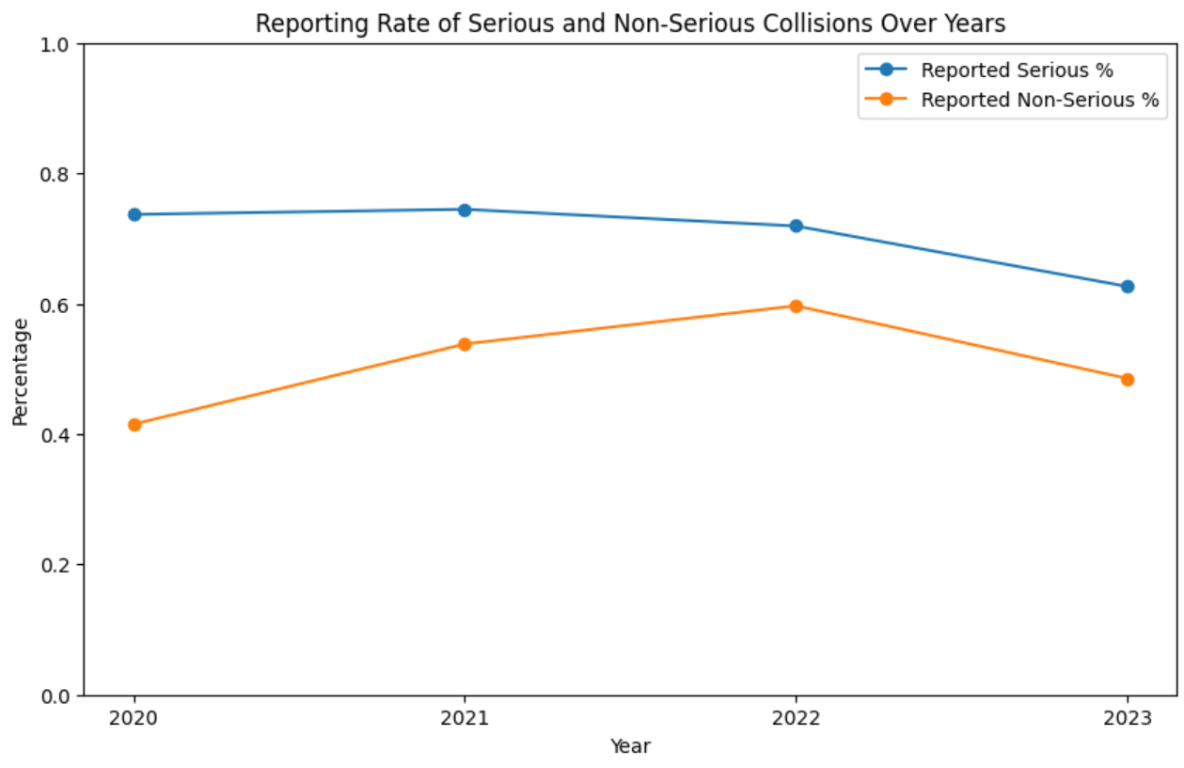

(Figure 13.1 - Reporting rate of serious and non-serious bike/ped collisions)

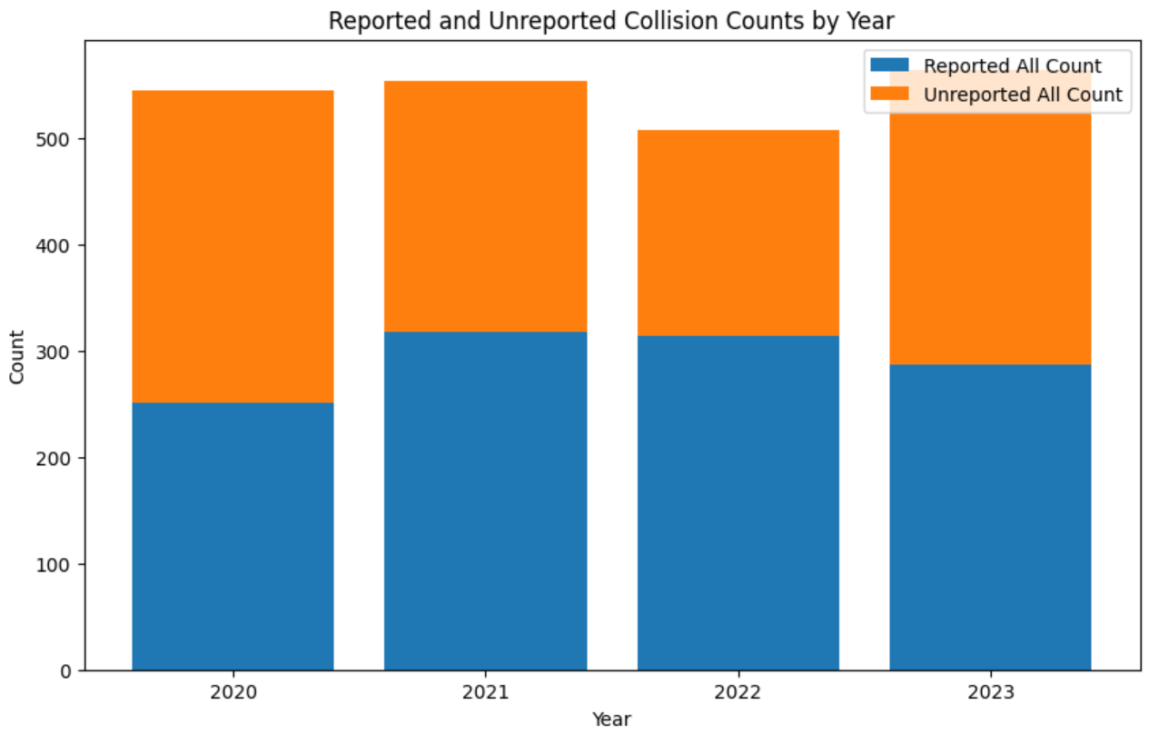

(Figure 13.2 - Reported/Unreported bike/ped collision counts by year)

Noisy and inconsistent input data hinders an automated model’s ability to fit. In this case, officer-generated reports, while populating a form, do not follow consistent conventions of event IDs and severity ratings making modeling effort difficult. It’s possible that resolving data relation issues will resolve most modeling quality issues. More effort is required to clean incoming data to achieve better joins and to more easily relate it with other datasets.

For now, the current output will be useful to produce summaries of most collisions, and to flag severe events for human review.

**Individual Feedback**

I paid a lot of attention to the high-level structure and organization of this project and found that I spent probably more time than will be graded on code format and directory tree. I sense that having clear and organized code will be a valuable characteristic of this project to keep it going after this course. Project/code structure is one thing that I thought could have been focused on more throughout the program. Even simple guidance on a typical python project tree and current conventions for project info I think would improve the course.

**Citations**

Abay, Kibrom A. (2015). Investigating the nature and impact of reporting bias in road crash data. *Transportation Research Part A: Policy and Practice*, *71*, 31–45. <https://doi.org/10.1016/j.tra.2014.11.002>

Ahmed, A., Sadullah, A. F. M., & Yahya, A. S. (2019). Errors in accident data, its types, causes and methods of rectification-analysis of the literature. *Accident Analysis & Prevention*, *130*, 3–21. <https://doi.org/10.1016/j.aap.2017.07.018>

baeldung. (2024). *How Many Principal Components to Take in PCA? | Baeldung on Computer Science*. <https://www.baeldung.com/cs/pca>

Bird, Steven, Klein, Ewan, & Loper, Edward. (2010). Chapter 2. Accessing Text Corpora and Lexical Resources. In Weibke Wagner (Ed.), *Natural Language Processing with Python*. <https://doi.org/10.1007/s10579-010-9124-x>

Burgess & Niple. (2021). *CUY - Cleveland PSIP Contract Proposal - 210192 PID 113330*. Ohio Department of Transportation. <https://contracts.dot.state.oh.us/common/searchAPI.do;jsessionid=c064FkjMF37QSwuiCcPlo8Azf8fS7ZAjgJAJnvbW.dotidpxep02?fetchCurrent=false&PID_NUM=113330&cabinetId=1002>

Chawla, N., Bowyer, K., Hall, L., and Kegelmeyer, P. (2002). SMOTE: Synthetic Minority Over-sampling Technique. *Journal of Artificial Intelligence*. <https://doi.org/10.1613/jair.953>

Cleveland, City of. (2023). *2022 Speed Table Pilot Program Evaluation and Key Recommendations*. <https://www.clevelandohio.gov/sites/clevelandohio/files/traffic/SpeedTablePilotEvaluationReport0523.pdf>

Cleveland, Vision Zero Task Force of. (2022). *Vision Zero Action Plan*. <https://www.visionzerocle.org/pages/action-plan>

Crawford, Murphy &. Tilly. (2018). *CUY-90-9.09 SAFETY STUDY*. https://ftp.dot.state.oh.us/pub/Districts/D12/Production/Consultant_Programmatic/2023_January/116831/CUY-90-9.09%20Safety%20Study%202018.06.30.pdf

Doggett, S., Ragland, D. R., & Felschundneff, G. (2018). Evaluating Research on Data Linkage to Assess Underreporting of Pedestrian and Bicyclist Injury in Police Crash Data. *UC Berkeley: Safe Transportation Research & Education Center*. <https://escholarship.org/uc/item/0jq5h6f5>

Explosion AI (n.d.). *Facts & figures · Spacy Usage Documentation*. Facts & Figures. <https://spacy.io/usage/facts-figures>

*Fine-tuning tutorial* (2024) *Google AI for Developers.* Available at: <https://ai.google.dev/gemini-api/docs/model-tuning/tutorial?lang=python> (Accessed: 4 November 2024).

Götschi, T., Garrard, J., & Giles-Corti, B. (2016). Cycling as a Part of Daily Life: A Review of Health Perspectives. *Transport Reviews*, *36*(1), 45–71. <https://doi.org/10.1080/01441647.2015.1057877>

Hauer, E., & Hakkert, A. S. (1988). Extent and Some Implications of Incomplete Accident Reporting. *Transportation Research Record*, *1185*. <http://onlinepubs.trb.org/Onlinepubs/trr/1988/1185/1185-001.pdf>

He, H., Bai, Y., Garcia, E. A., and Li, S. (2008). ADASYN: Adaptive Synthetic Sampling Approach for Imbalanced Learning. *2008 IEEE International Joint Conference on Neural Networks (IEEE World Congress on Computational Intelligence)*, 1322–1328. <https://doi.org/10.1109/ijcnn.2008.4633969>

Honnibal, M., & Montani, I. (2020). spaCy: Industrial-strength natural language processing in Python. https://spacy.io. <https://doi.org/10.5281/zenodo.1212303>

HuggingFace. (2024). *Token Classification*. Retrieved October 20, 2024, from <https://huggingface.co/docs/transformers/tasks/token_classification>

Jiang, A. Q., Mensch, A., Bamford, C., Chaplot, D. S., Casas, D. de las, Bressand, F., Lengyel, G., Lample, G., Saulnier, L., Lavaud, L. R., Lachaux, M.-A., Stock, P., Scao, T. L., Lavril, T., Wang, T., Lacroix, T., Sayed, W. E., and Sablayrolles, A. (2023). *Mistral.AI*. <https://doi.org/10.48550/arxiv.2310.06825>

Kamath, Uday, Liu, John, & Whitaker, James. (2019). *Deep Learning for NLP and Speech Recognition*. <https://doi.org/10.1007/978-3-030-14596-5>

Khadka, Anish, Parkin, John, Pilkington, Paul, Joshi, Sunil Kumar, & Mytton, Julie. (2022). Completeness of police reporting of traffic crashes in Nepal: Evaluation using a community crash recording system. *Traffic Injury Prevention*, *23*(2), 79–84. <https://doi.org/10.1080/15389588.2021.2012766>

Kuntzman, G. (2024) *Huge grant: Feds send city $12M to improve Post-Crash analyses - Streetsblog New York City.* (2024, September 6). <https://nyc.streetsblog.org/2024/09/06/huge-grant-feds-send-city-12m-to-improve-post-crash-analyses>

Learn, Imbalanced. (n.d.). *Over-sampling methods — Version 0.12.4*. Retrieved October 13, 2024, from <https://imbalanced-learn.org/stable/references/over_sampling.html>

Moll, Cameron. (2022). *Abraham Wald and the airplane diagram with red bullet holes – here’s the origin story*. <https://www.cameronmoll.com/journal/abraham-wald-red-bullet-holes-origin-story>

Naumann, Rebecca B., Heiny, Stephen, Evenson, Kelly R., LaJeunesse, Seth, Cooper, Jill F., Doggett, Sarah, & Marshall, Stephen W. (2019). Organizational networks in road safety: Case studies of U.S. Vision Zero cities. *Traffic Injury Prevention*, *20*(4), 378–385. <https://doi.org/10.1080/15389588.2019.1587752>

Nguyen, H. M., Cooper, E. W., and Kamei, K. (2011). Borderline over-sampling for imbalanced data classification. *International Journal of Knowledge Engineering and Soft Data Paradigms*, *3*(1), 4. <https://doi.org/10.1504/ijkesdp.2011.039875>

ODOT. (2022). *Safety Analysis Guidelines*. <https://www.transportation.ohio.gov/programs/highway+safety/highway-safety-manual-guidance/safety-analysis-guidelines-cf/search>

ODOT. (2023). *Ohio Highway Safety Improvement Program 2023 Annual Report*. <https://highways.dot.gov/sites/fhwa.dot.gov/files/2024-04/HISP%28Ohio%29%202023%20Report.pdf>

Ohio Department of Transportation (ODOT). (n.d.). Ohio Crash Report Procedure Manual. In <https://dam.assets.ohio.gov/image/upload/publicsafety.ohio.gov/HSY7010.pdf>.

OSHP Statistical Analysis Unit. (2024). *Ohio Statistics and Analytics for Traffic Safety User Guide*. Ohio State Highway Patrol. <https://dam.assets.ohio.gov/image/upload/statepatrol.ohio.gov/links/OSTATS_PublicUserGuide_2024.pdf>

ORC. §5502.11 (2011). *Written Report of Motor Vehicle Accident*. <https://codes.ohio.gov/ohio-revised-code/section-5502.11>

Police Scorecard. (n.d.). *Scorecard at a Glance: Cleveland, OH*. Police Scorecard: Cleveland, OH. <https://policescorecard.org/oh/police-department/cleveland>

Porter, M. F. (1980). An algorithm for suffix stripping. *Program*, *Volume 14*(Issue 3), 130–137. <https://doi.org/10.1108/eb046814>

Scott, Robert, & Carroll, Philip. (1971). Acquisition of Information on Exposure and on Non-Fatal Crashes - Accident Data Inaccuracies Vol. II. *Highway Safety Research Institute, The University of Michigan Ann Arbor, Michigan*. <https://deepblue.lib.umich.edu/bitstream/handle/2027.42/1054/15848.0001.001.pdf>

Shahine, M. (2024, May 5). Gemini AI: A Breakthrough in Multimodal AI | ProfileTree. ProfileTree Web Design and Digital Marketing. <https://profiletree.com/gemini-ai-a-breakthrough-in-multimodal-ai/>

Social Security Administation (2024) *Popular Baby Names*. Available at: <https://www.ssa.gov/OACT/babynames/> (Accessed: 17 November 2024).

Song, X., & Zhou, D. (2021, December 10). A Fast WordPiece Tokenization System. Research.google. <https://research.google/blog/a-fast-wordpiece-tokenization-system/>

U.S. Census (2023) *U.S. Census Bureau quickfacts: Cleveland City, Ohio*. Available at: <https://www.census.gov/quickfacts/fact/table/clevelandcityohio/PST045223> (Accessed: 22 November 2024).

Wald, Abraham. (1980). Reprint of Estimating Plane Vulnerability Based on Damage of Survivors. *Center for Naval Analysis*. <https://lru.praxis.dk/Lru/microsites/virksomhederiundervisningen/novo_materiale/9-A%20method%20of%20estimating%20plane%20vulnerability%20....pdf>

Xu, W., Napoles, C., Pavlick, E., Chen, Q., and Callison-Burch, C. (2016). Optimizing Statistical Machine Translation for Text Simplification. *Transactions of the Association for Computational Linguistics*, *4*, 401–415. <https://doi.org/10.1162/tacl_a_00107>